
Compte Rendu Complete de TP Q&T

Made by: Ahmed R. Hedhili

Supervised by: Dr. Amen Bidani



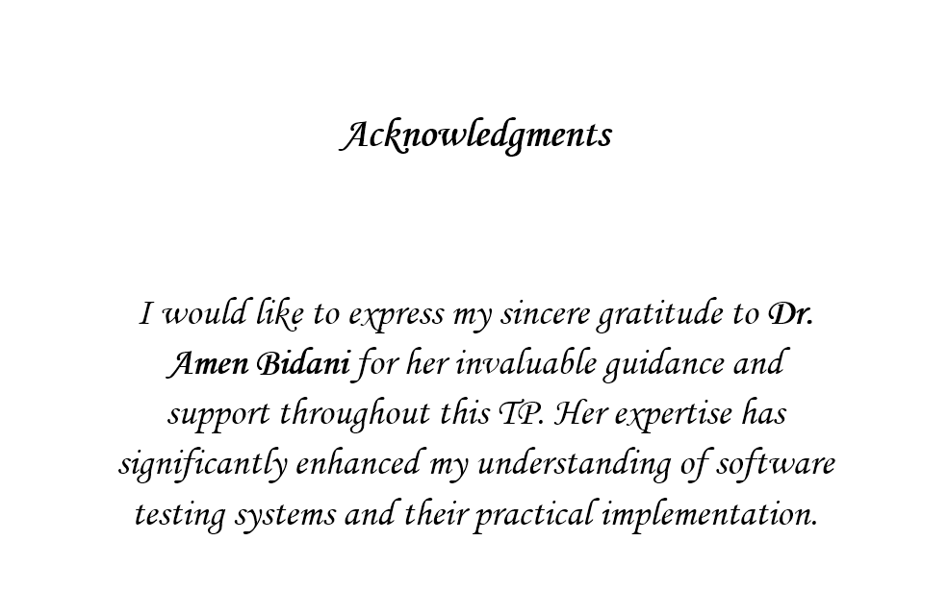

Table of Contents

TP1: Unit Testing in Java using JUnit 5 4
TP2: Test Driven Development in Java 13
TP3: Automated testing with JUnit and Spring 21
TP4: Integration tests and BDD methodology 30
TP5: ChatGPT to facilitate software test automation 38
TP++: Testing using Python and PyTest 46

TP1: Unit Testing in Java using JUnit 5

Introduction
Unit testing is a fundamental pillar in the software development lifecycle, aiming to isolate specific parts of code and verify their correct and independent functionality. This part of report focuses on how to set up and execute these tests in a Java environment using the JUnit 5 framework, based on the educational content provided in the attached document.

Core Concepts of Unit Testing
The basic process of testing a software unit involves the following steps:
- Instantiation: Create an object of the class to be tested.
- Initialization: Set up the initial state of the object.
- Execution: Invoke the method to be tested with the necessary parameters.
- Verification: Compare the actual result with the expected result using assertions.

The JUnit 5 Framework
JUnit is an open-source and widely used framework for automating unit tests in Java. This framework ensures that the code still meets software requirements even after modifications or improvements, which is known as "non-regression" testing.

Annotations in JUnit 5
Annotations are used to guide the framework on how to handle test methods. The following table illustrates the most important annotations used:

Annotation | Purpose
@Test | Designates a method as a test method.
@BeforeEach | Executes the method before each test (ideal for setting up prerequisites).
@AfterEach | Executes the method after each test (ideal for cleanup operations).
@BeforeAll | Executes the method once before all tests (must be static).
@AfterAll | Executes the method once after all tests (must be static).
@Timeout | Specifies a maximum time for test execution; if exceeded, the test fails.

Practical Application using NetBeans Environment
Setting up a test project in NetBeans involves the following steps:

1. Project Creation:
Create a new project by selecting **Java with Maven > Java Application**.
This ensures automated dependency management and a standardized project structure.

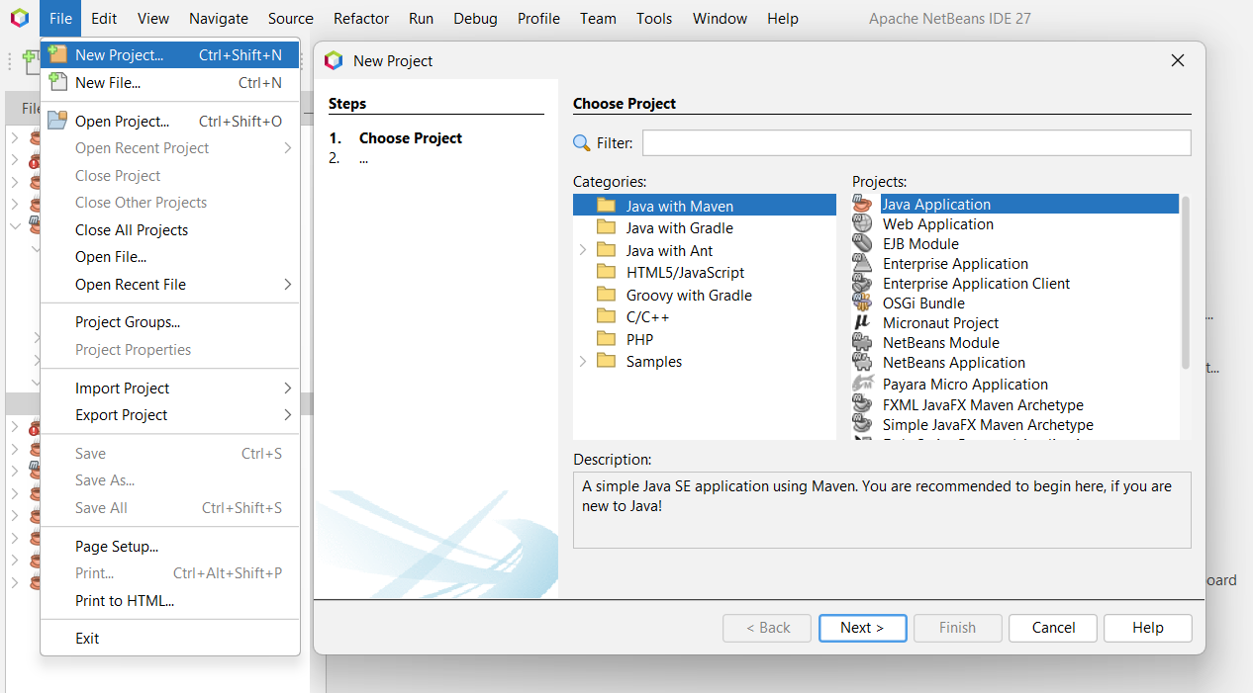

2. Configuring Dependencies:
Since some NetBeans versions do not natively support JUnit 5 in the default "Create Test" dropdown, the framework must be added manually.
This is achieved by editing the pom.xml file and inserting the JUnit 5 (Jupiter) dependency within the <dependencies> section. This step forces the IDE to fetch and integrate the modern testing library.
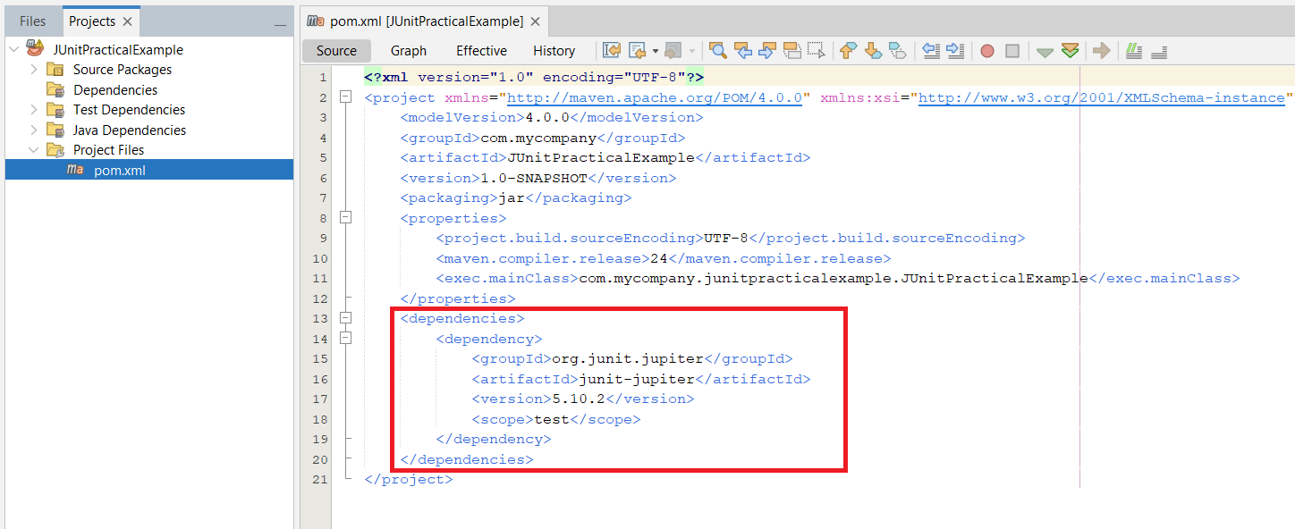

3. Source Code Implementation:
Create a package (e.g., fr.koor.poo) under Source Packages and implement the class to be tested, such as the Rational class, ensuring all business logic is correctly defined.

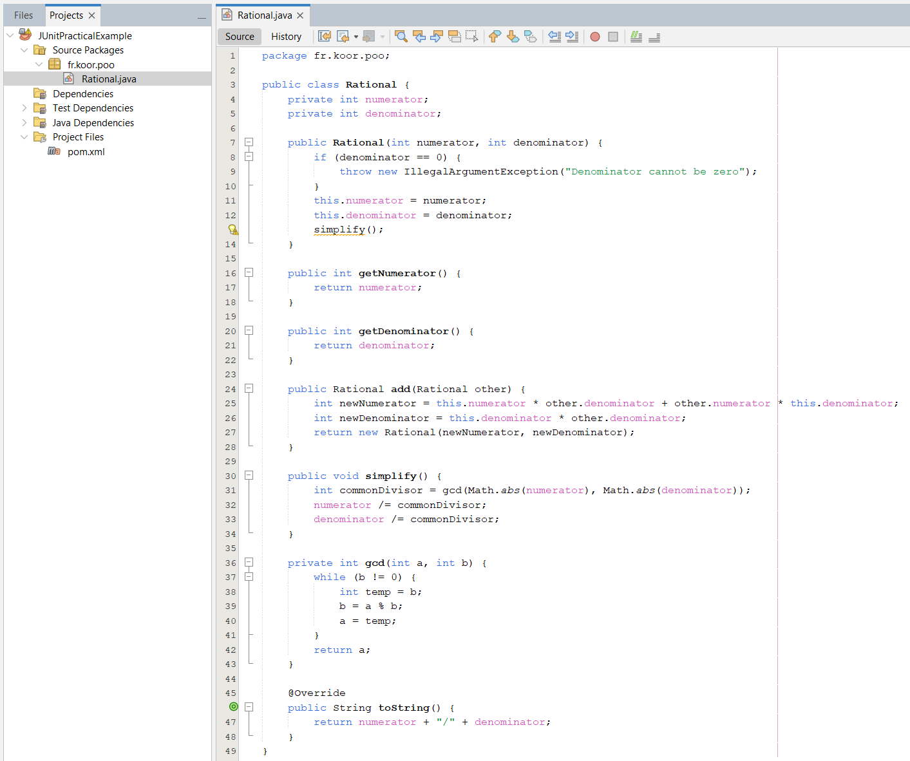

4. Generating Test Cases:
Right-click the class file and select **Tools > Create/Update Tests**.
Even if you select "JUnit" from the limited dropdown, you can then manually update the generated test file to use JUnit 5 imports (like org.junit.jupiter.api.Test) and modern features like assertThrows.

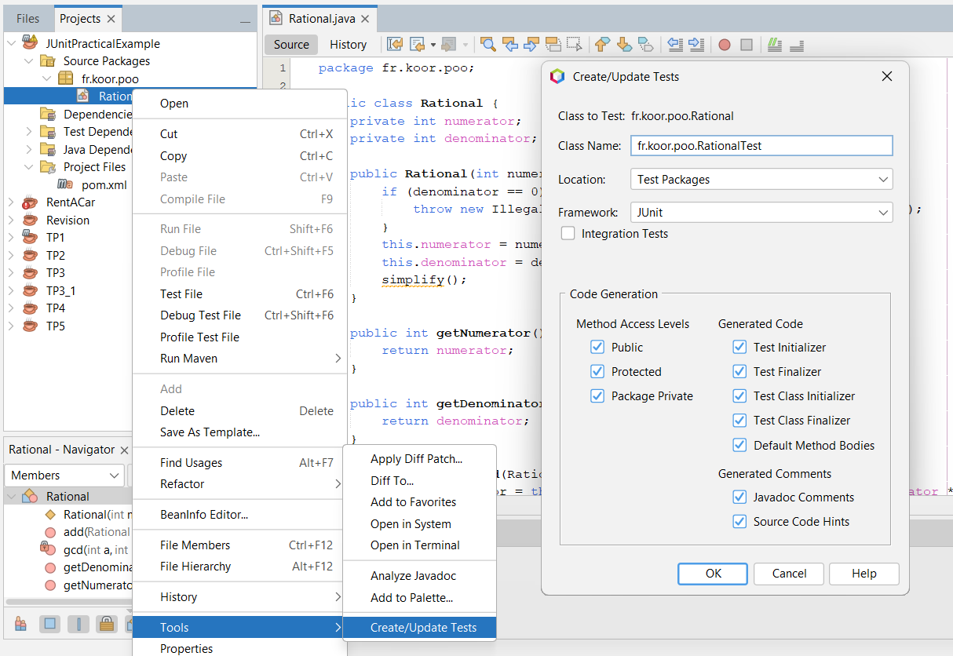

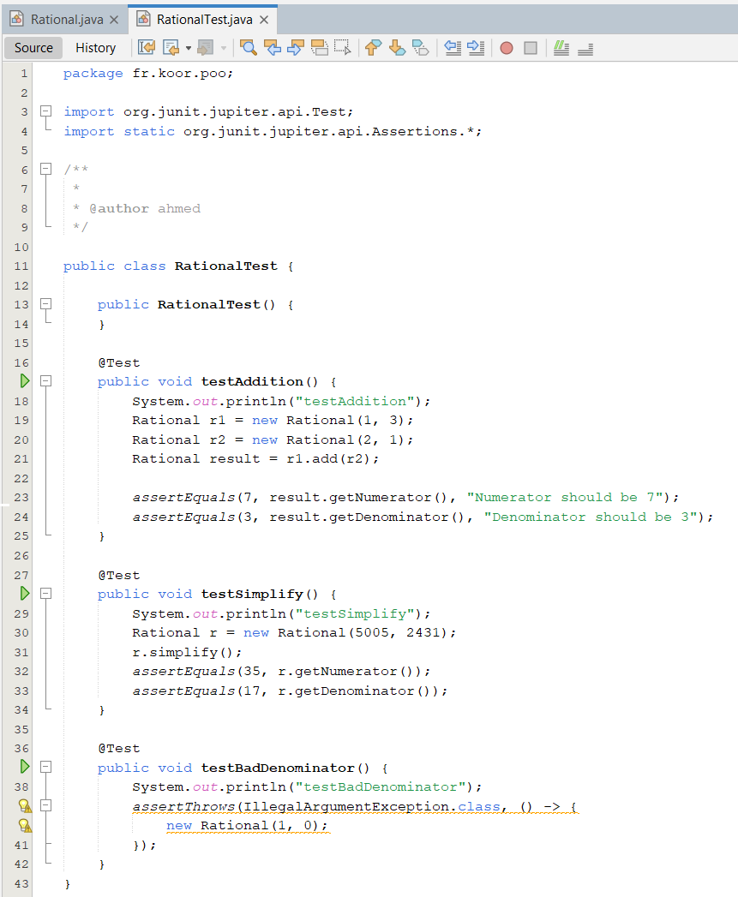

5. Execution and Verification:
Run the tests by pressing Alt + F6. The Test Results window will confirm the success, proving that the Manual Maven configuration successfully integrated JUnit 5 into the environment.

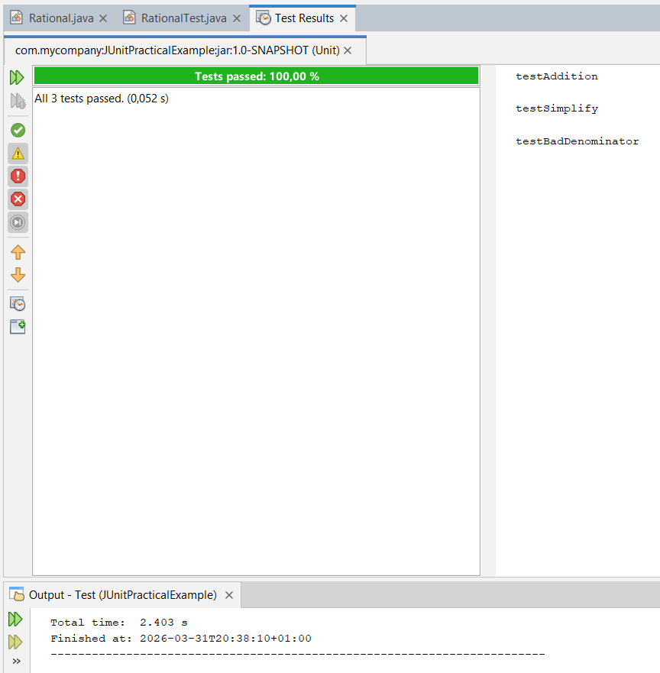

6. Test Lifecycle:
Test methods follow a specific chronological sequence:
- @BeforeAll is invoked once before all tests.
- For each @Test method: @BeforeEach is invoked, then the test is executed, then @AfterEach .
- @AfterAll is invoked once at the end.

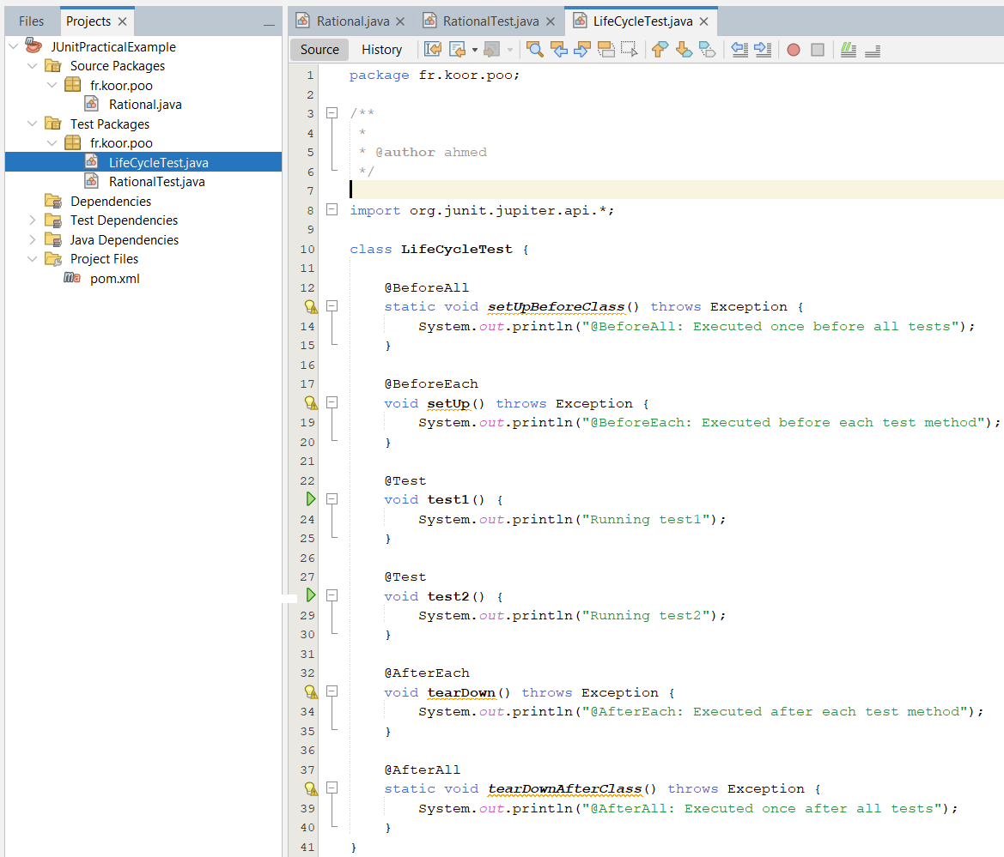

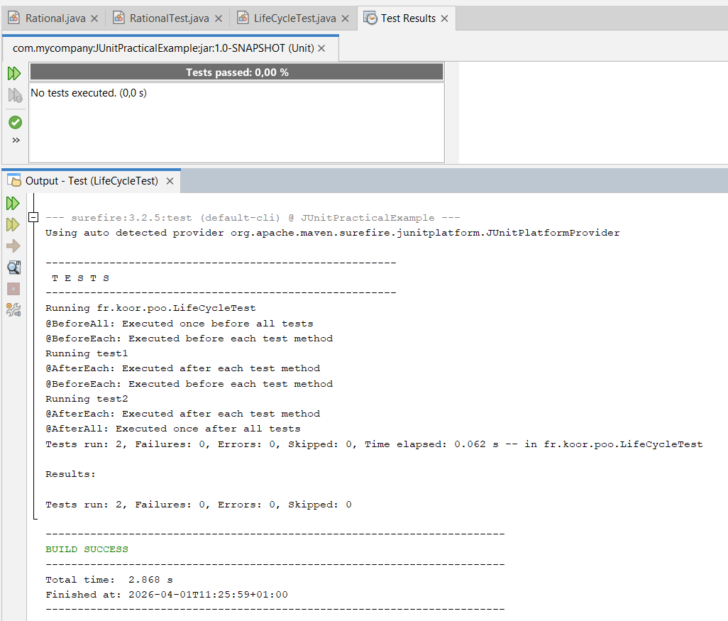

Conclusion
JUnit 5 is a powerful tool that directly contributes to improving the quality of software applications. By integrating automated tests into the development process, programmers can detect errors early and ensure code stability in the long term.

TP2: Test Driven Development in Java

Introduction to TDD (Test Driven Development)

Test Driven Development is a software development methodology based on a very short iteration cycle. Instead of writing code first and then testing it, we write the test first, then write the minimum amount of code to make that test pass and finally refactor the code.

The TDD Lifecycle (Red-Green-Refactor):
- Red Phase: Write a test that fails (or doesn't even compile because the code doesn't exist yet).
- Green Phase: Write the minimum amount of code to make the test pass.
- Refactor Phase: Improve and organize the code while ensuring that the tests remain successful.

Case Study: The Wolf Object (Loup)
The practical example in the document aims to create a "Wolf" object that can rotate clockwise (North, East, South, West), starting from the North position.
Phase 1: Creating the Project and Starting the Test (Red Phase):
- Create a new Maven project: As we did previously, choose **Java with Maven > Java Application** and name it TDDWolfProject.
- Add the JUnit 5 library: Don't forget to add the dependency in the pom.xml file as we learned in the first TP.
- Go to Test Packages and create a new test class called LoupTest.

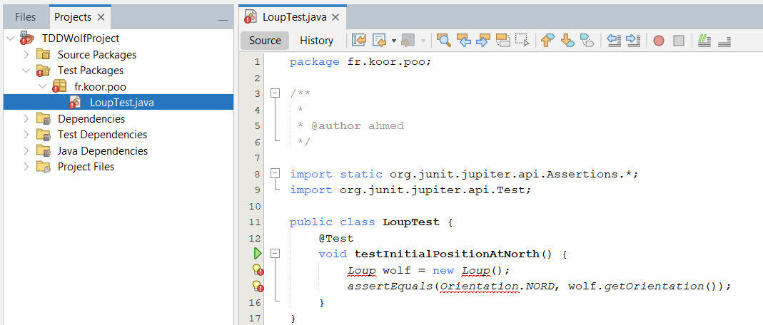

Observation: The code won't be compiled initially because the Loup and Orientation classes don't exist.
Phase 2: The Minimalist Solution (Green Phase):
Now, we will write as little code as possible just to make this test succeed
- Creating the Enum: Create a new file named Orientation:
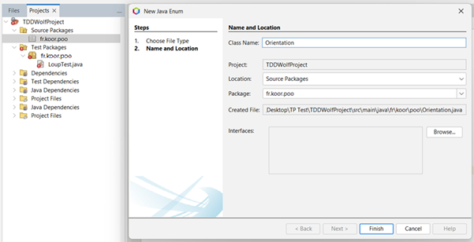

The Enum (short for Enumeration) is a special type in Java used to represent a fixed set of values ​​(such as directions, days of the week, colors). In our example, we used it to ensure that the wolf's direction would not deviate from these four possibilities.

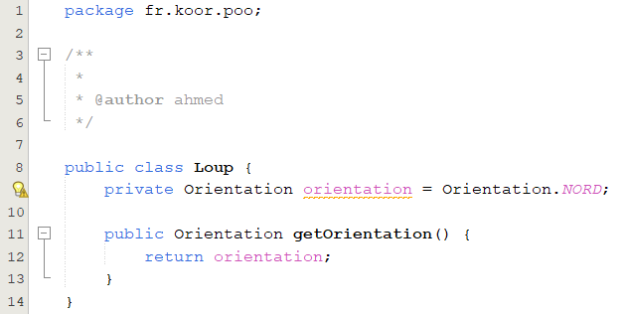
- Creating a Loup class:

- To operate: Press Alt + F6. You will get the green bar!
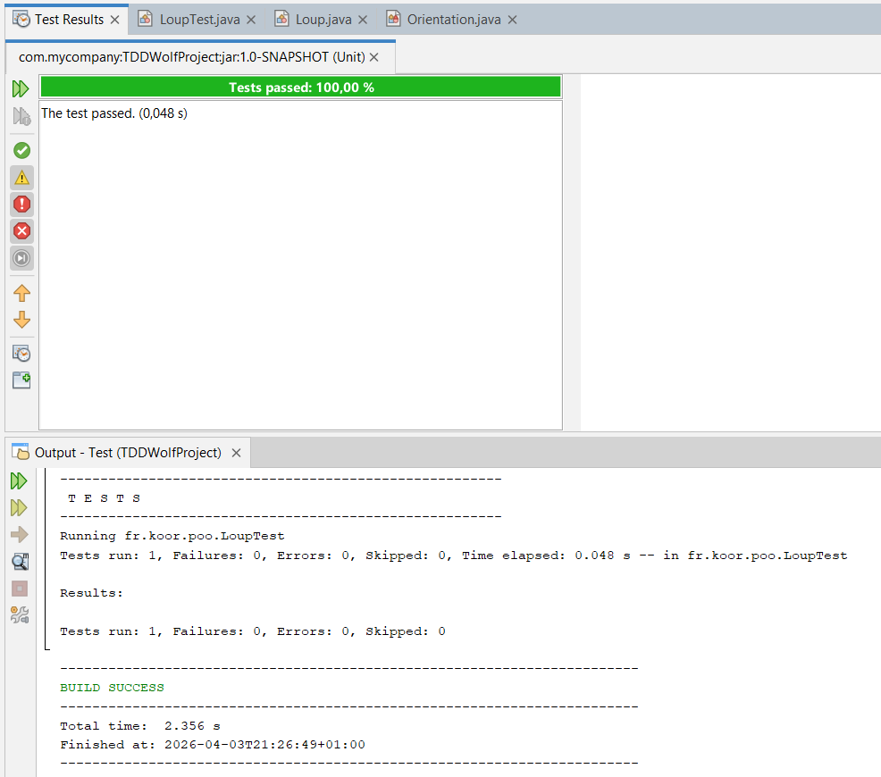

Phase 3: Adding the rotation feature (cycle repetition):
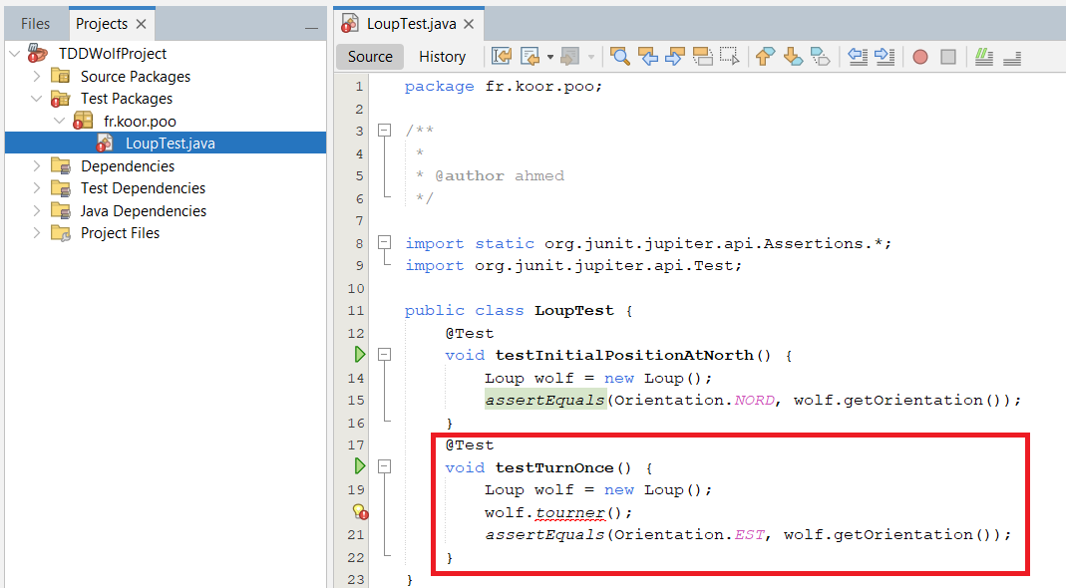
- A new test will be added to LoupTest:

Execution: The code will fail (red)
- Go to the Loup class and add the tourner() function to give the desired result:
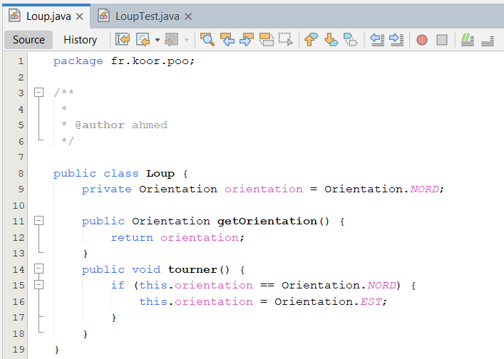

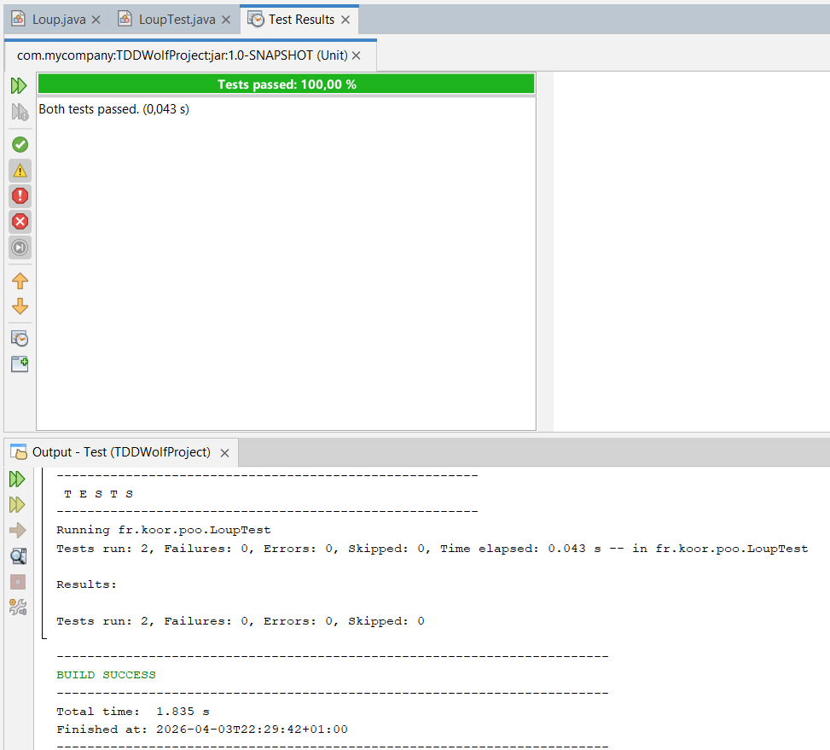

Phase 4: Refactoring:
Instead of using a lot of repetitive if-else statements, we will use Switch Expression:

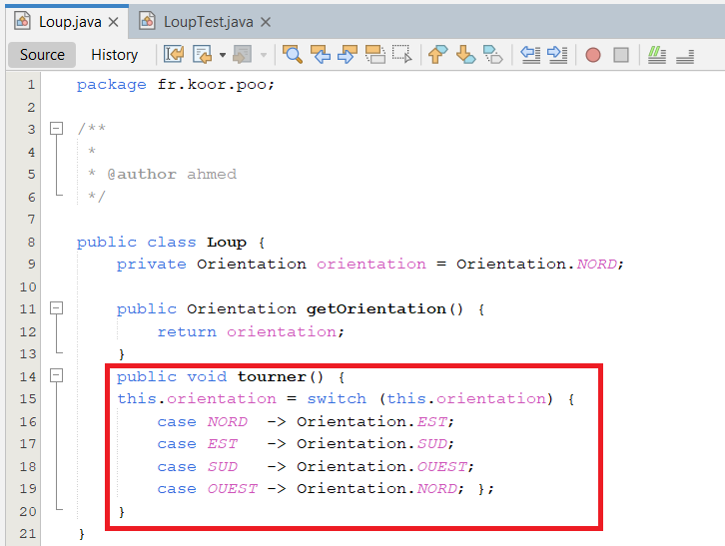

The code is now very clear and easy to read, and will ensure coverage of all cases.
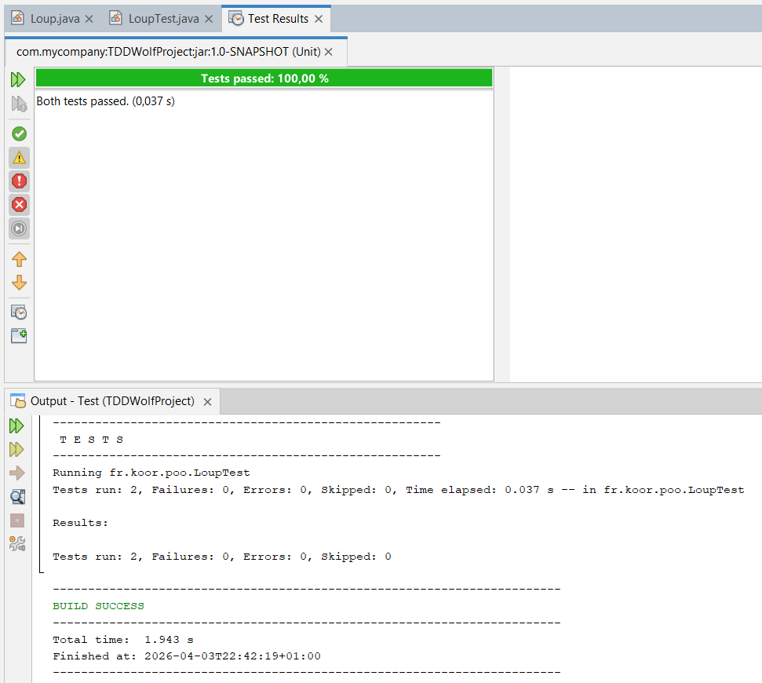

Conclusion
Test-Driven Development (TDD) is a sophisticated software engineering practice that prioritizes reliability and design from the very beginning. By adopting the "test-first" approach, developers can ensure that every feature is precisely implemented according to requirements while maintaining a clean and maintainable codebase. Ultimately, TDD empowers programmers to build robust Java applications with the confidence that new changes will not compromise existing functionality.

TP3: Automated testing with JUnit and Spring

Introduction to Testing in Spring Architecture
In a standard professional architecture, the Service Layer (containing business logic) and the Data Access Layer (DAO) (containing database queries like JDBC or Hibernate) are strictly separated.
• Transactions are typically managed by the Service Layer.
• Spring Framework allows automatic transaction management using annotations or programmatic approaches, with or without Spring Boot.

Practical Application:
Testing with Spring Boot in NetBeans
Integrating JUnit 5 with the Spring Framework allows for robust integration testing. The following steps outline the practical implementation in a NetBeans Maven environment:
- Dependency Configuration:
The spring-boot-starter-test and spring-boot-starter dependencies are added to the pom.xml file. This bundle provides the necessary libraries for both the Spring core and the testing suite (JUnit 5, Mockito, etc.).
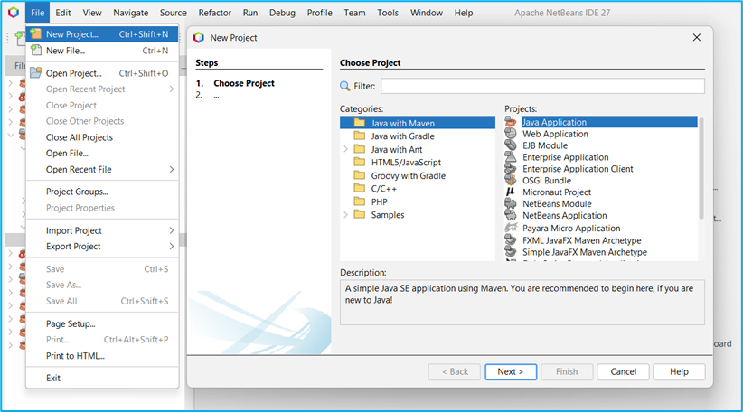

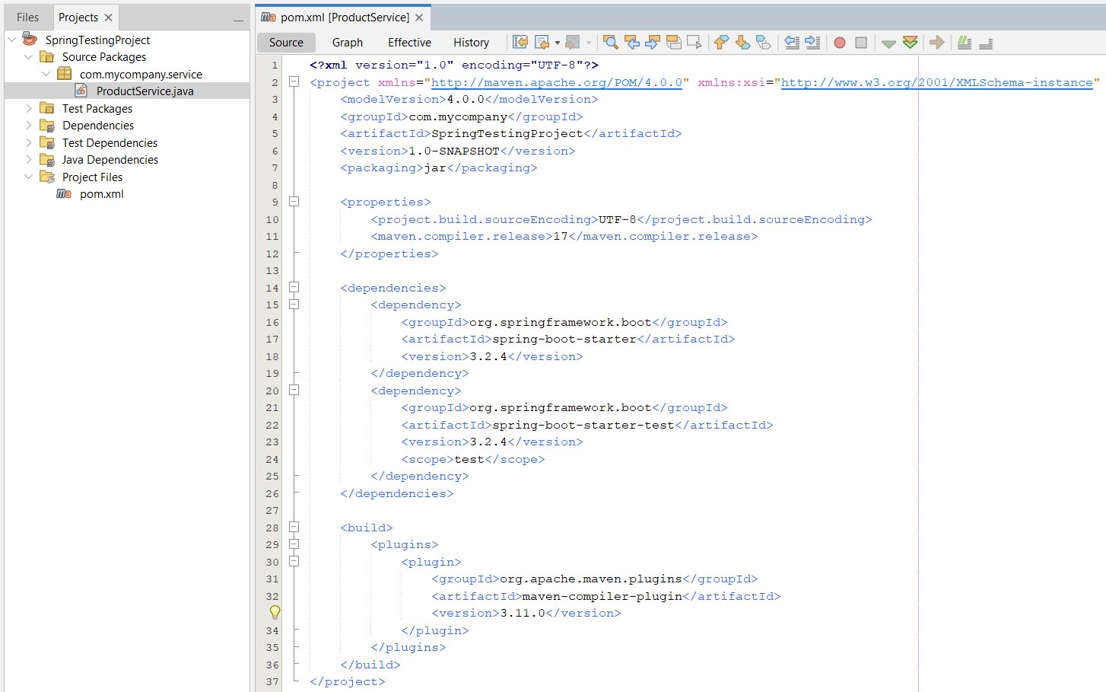

- Component Implementation:
A service class (e.g., ProductService) is created and annotated with @Service. This informs Spring that the class is a "Bean" or a managed component that can be automatically instantiated and managed within the application context.
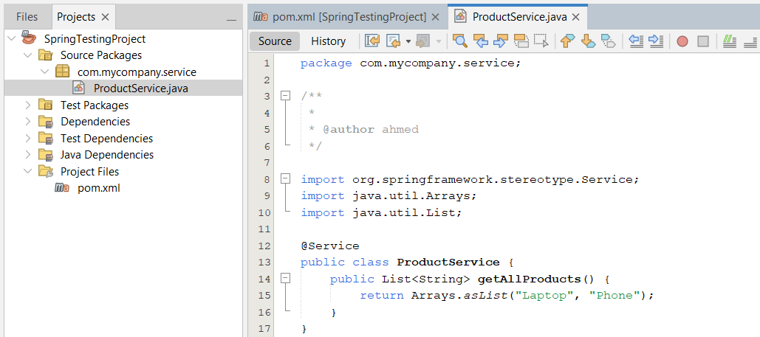

- Dependency Injection (@Autowired):
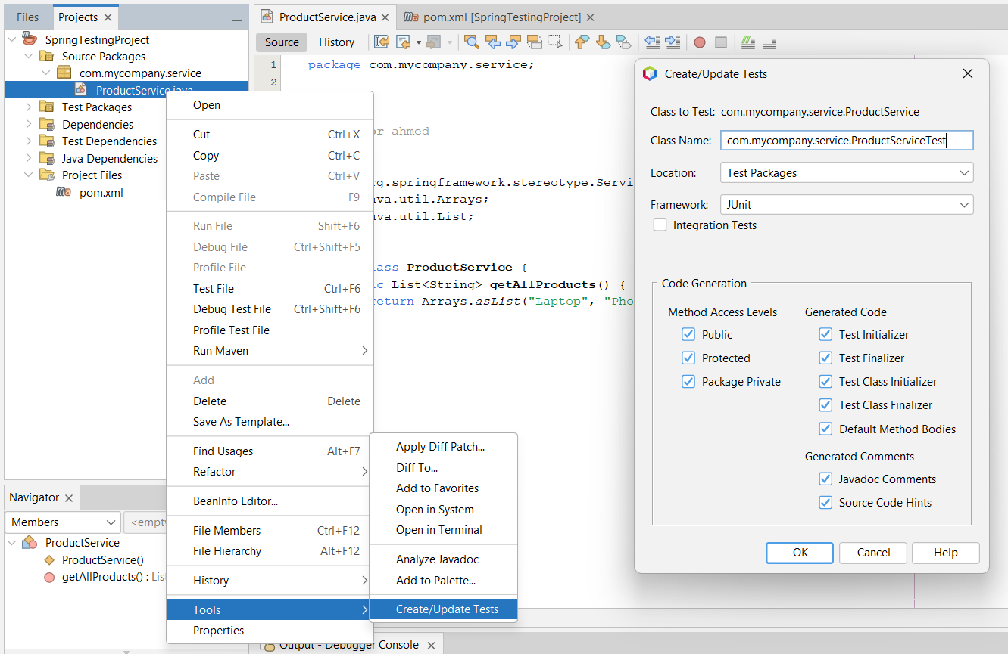
Instead of manually instantiating services, we use the @Autowired annotation to inject the ProductService bean directly into the test class. This ensures that the service is tested with all its internal dependencies correctly managed by Spring.

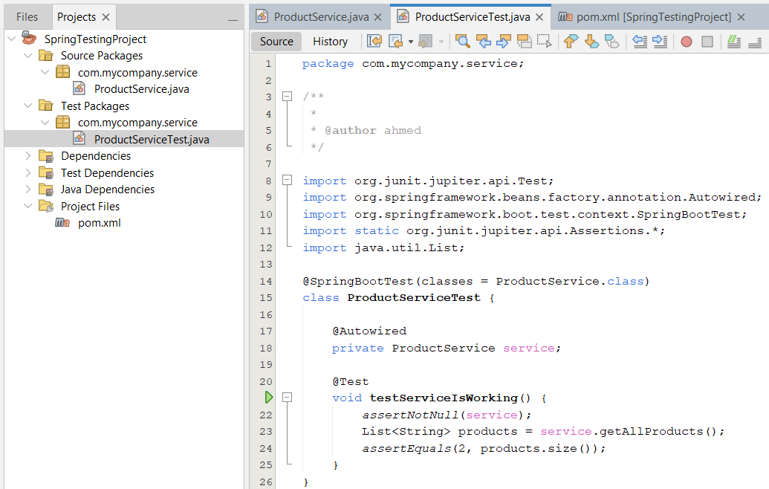

Execution: Tests are executed using Alt + F6. NetBeans displays the Spring Boot startup logs in the Output window, followed by the test results, ensuring that the entire component chain is functioning correctly.
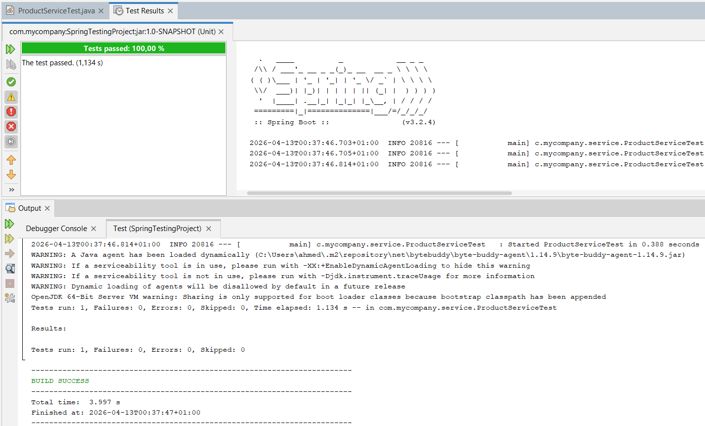

Transactional Testing with @Transactional:
In enterprise applications, tests often interact with a database. To maintain data integrity and isolation, the @Transactional annotation is applied to the test class. This ensures that every database operation performed during a test is automatically rolled back upon completion. This prevents tests from polluting the database with "garbage" data and ensures that each test starts with a consistent and predictable state.

- Dependency Management:
The spring-boot-starter-data-jpa dependency was added to pom.xml to provide the necessary transaction management infrastructure.
To support database operations during testing, the H2 Database (in-memory) dependency was included. This allows Spring to simulate a database environment without requiring an external SQL server installation.
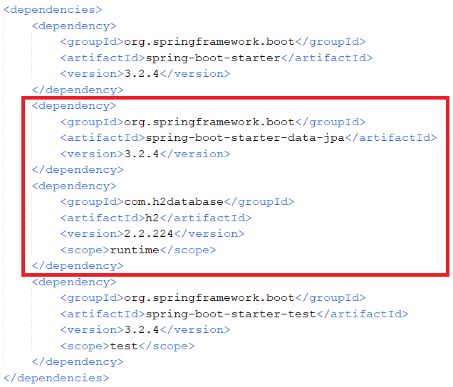

- Application Context Configuration:
A main application class, SpringTestingProjectApplication, was created with the @SpringBootApplication annotation. This class serves as the "root" for Spring’s component scanning, enabling the test framework to locate and initialize the @Service beans (like ProductService).
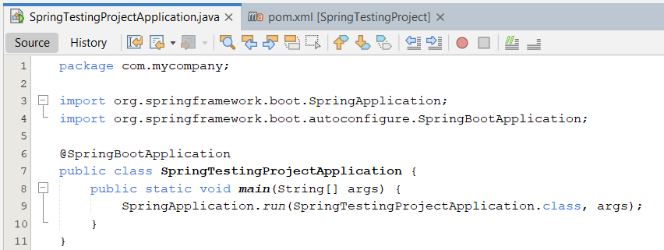

- Applying the @Transactional Annotation:
The @Transactional annotation was applied at the class level of the ProductServiceTest. This informs the Spring TestContext Framework that every test method within this class should be executed within a managed database transaction.
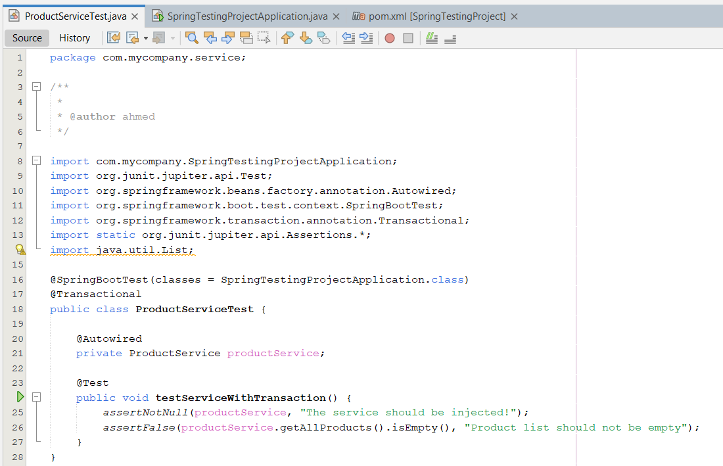

Test Class Integration: The test class was annotated with @SpringBootTest(classes = SpringTestingProjectApplication.class). By explicitly defining the classes parameter, we ensured that the test environment correctly loads the application’s configuration even when files are located in different packages.
Automatic Rollback: By default, Spring's testing framework automatically triggers a Rollback at the end of each test method. This ensures that any data created or modified during the test is never committed to the database, keeping the environment consistent for subsequent tests.

- Verification through Logs:
Upon execution (using Alt + F6), the Spring Boot console logs confirm the transaction management by displaying messages such as:
- Began transaction for test context...
- Rolled back transaction for test context...

Benefits Realized: This approach eliminates the need for manual database cleanup and prevents "dirty data" from affecting the reliability of the test suite, resulting in faster and more predictable automated tests.
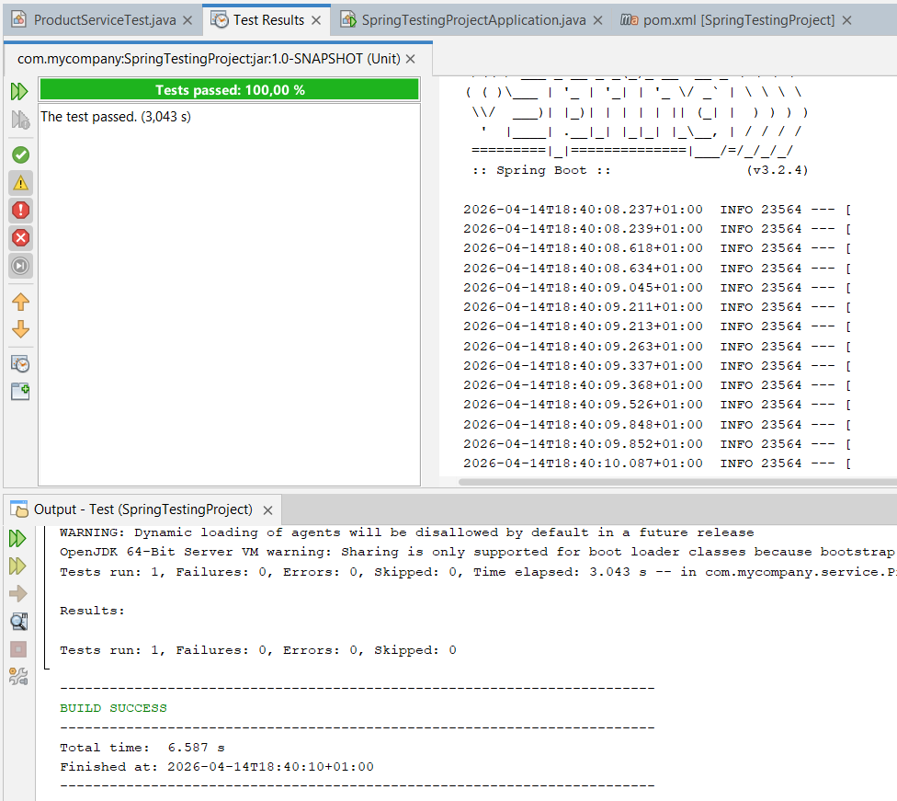

Conclusion
Testing in a Spring environment transition from simple unit tests to comprehensive Integration Tests. By leveraging Spring's robust testing support—specifically @SpringBootTest for context loading and @Transactional for automatic rollback—developers can ensure that business logic and database interactions work seamlessly together. This approach guarantees a clean, automated, and isolated test suite, ensuring that the application remains reliable and production-ready without the overhead of manual database management.

TP4: Integration tests and BDD methodology

Introduction
In modern software engineering, ensuring that individual modules work harmoniously is critical. We will explore Integration Testing through the lens of Behavior-Driven Development (BDD). By leveraging the Cucumber-JVM framework, developers can bridge the communication gap between technical teams and business stakeholders, translating plain-language requirements into executable, automated test suites.

Practical Steps
Note: these Maven-based steps are fully compatible with NetBeans and other major IDEs.

- Project Architecture:
Utilizing the maven-archetype-quickstart to create a standardized directory structure that adheres to the "Convention over Configuration" principle.
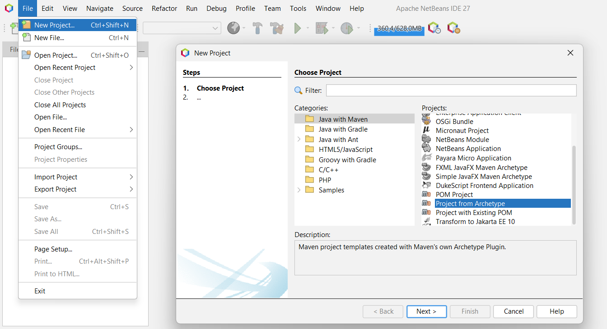

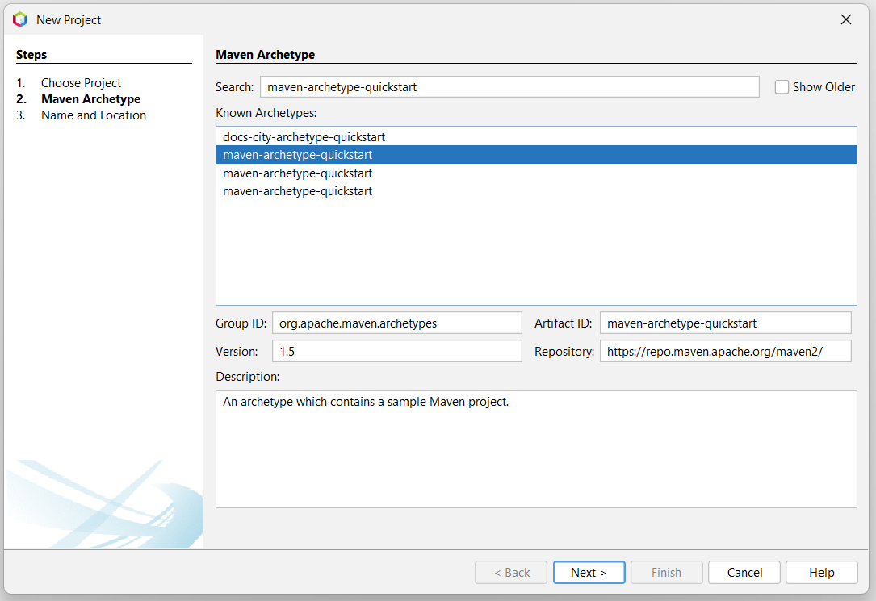

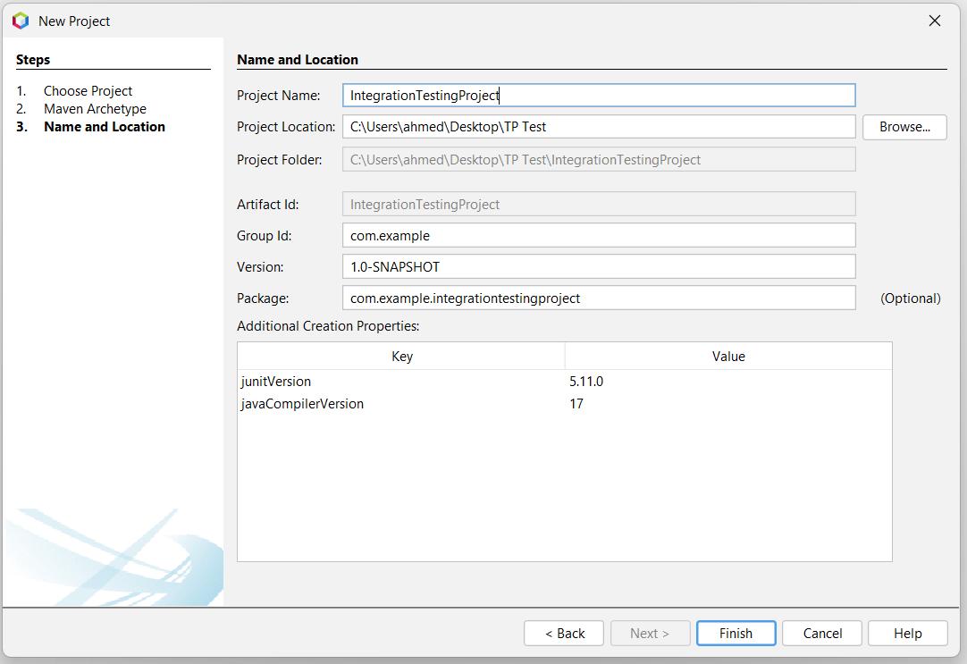

- Dependency Management:
Integrating core libraries within the pom.xml file, specifically cucumber-java for the BDD engine and cucumber-junit for test execution and reporting.

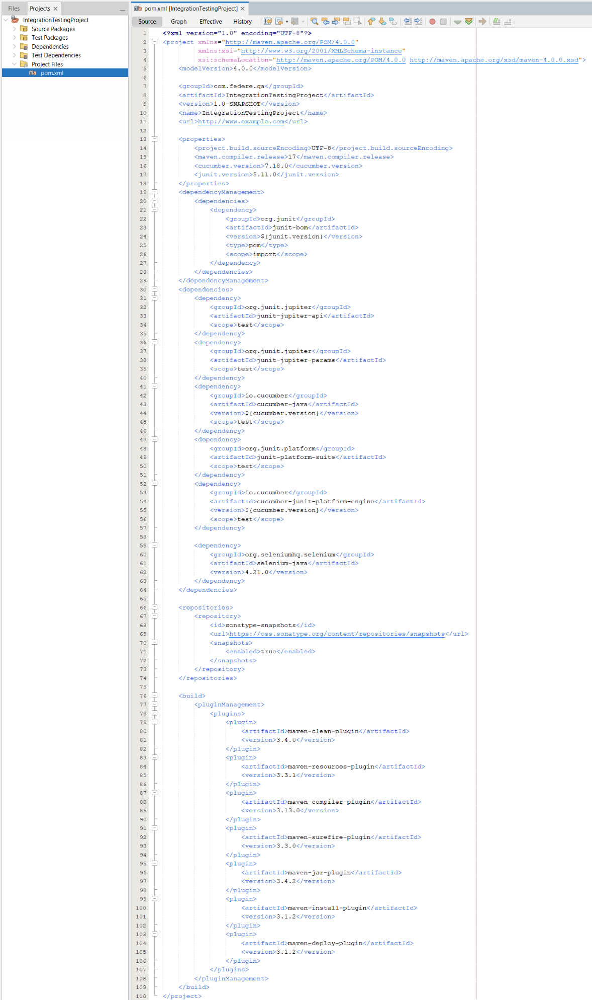

- Resource Organization:
Creating a dedicated src/test/resources directory to house Gherkin feature files, ensuring a clean separation between testing logic and test specifications.
- Script file (game.feature):
This file describes the game's behavior in simple language that everyone can understand.
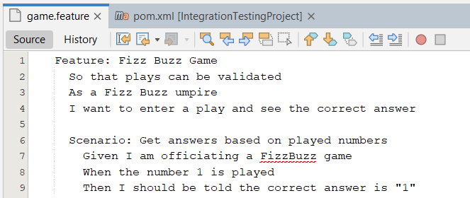

- The programming link file (StepDefinitions.java):
This code links the statements written in the Feature file to the programming logic in Java.
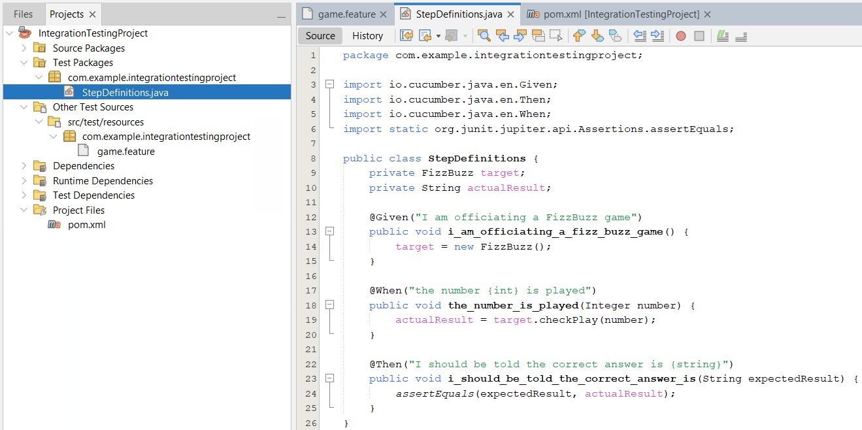

- The Programming logic file (FizzBuzz.java):
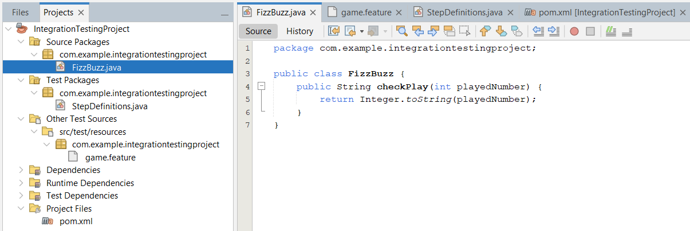

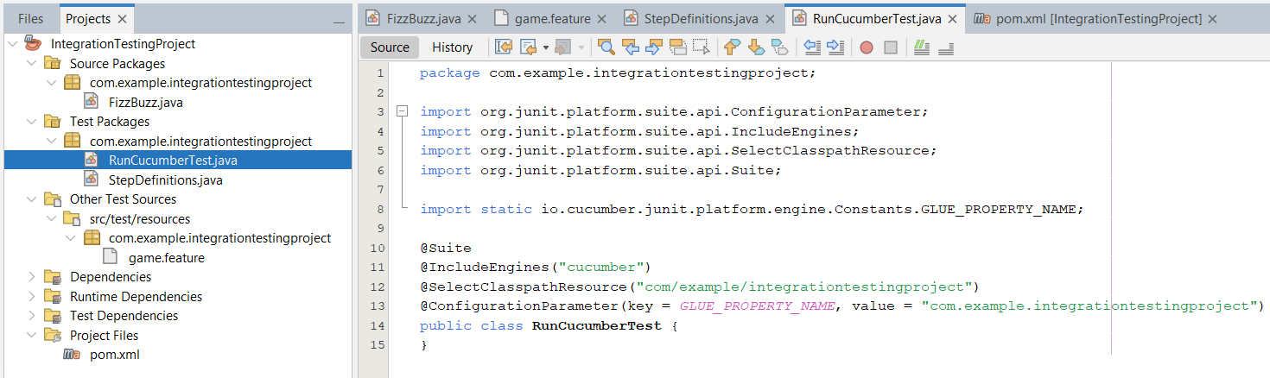
- The Test Runner file (RunCucumberTest.java):

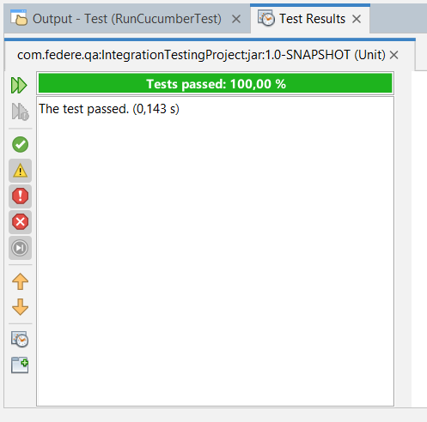
- Execution: When you run the test, a window called Test Results will appear, and you will see a green bar if everything is correct.

- Developing the logic of the game (The Challenge):
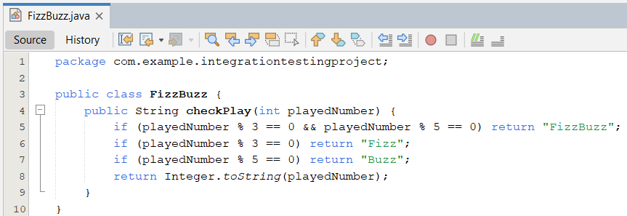

- Adding new scenarios (Scaling):
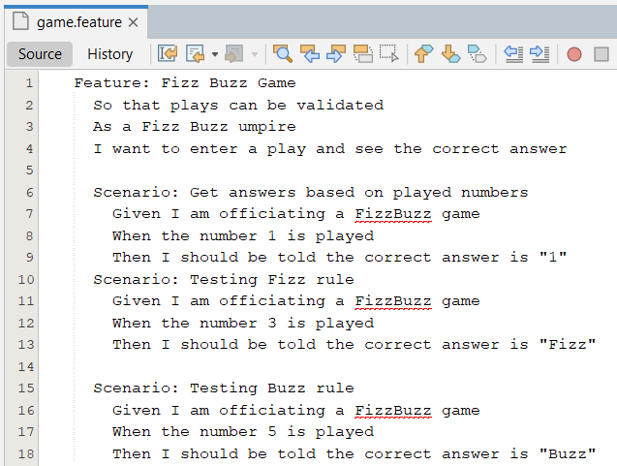

- Execution: Run the RunCucumberTest.java file again
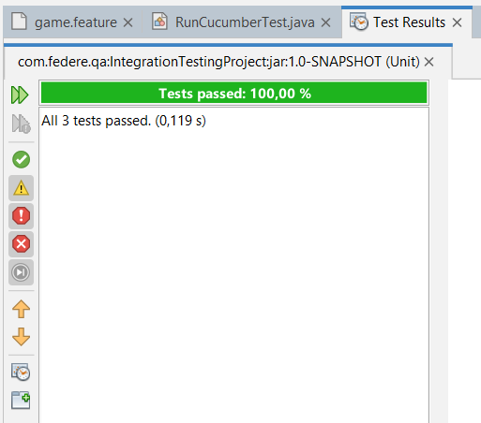

Conclusion
The shift toward BDD and automated integration testing represents a significant leap in software quality assurance. By utilizing Gherkin-based scenarios, we bridge the gap between technical implementation and business requirements. While tools like ChatGPT can drastically accelerate the generation of initial test scripts, the human element remains indispensable for architectural decisions, security enforcement, and the maintenance of a resilient CI/CD pipeline. This comprehensive approach ensures that software is not just functional, but also secure and maintainable in the long term.

TP5: ChatGPT to facilitate software test automation

Introduction
As software delivery cycles accelerate, AI-driven tools like ChatGPT are emerging as critical force multipliers for Quality Assurance teams. This section examines how conversational AI facilitates "shift-left" testing by automating the creation of comprehensive test scenarios, reducing the overhead of script maintenance, and architecting robust testing infrastructures. We explore the tangible efficiency gains offered by these tools while addressing the critical limitations and "hallucinations" that require human oversight, offering a realistic roadmap for AI-augmented test automation abilities.

Objectives and Initial Use Cases
The primary objective is to leverage ChatGPT to simplify and enhance the workflow of web and mobile application testers, with a particular focus on test automation. The initial use cases involve generating basic test cases for common scenarios, such as search functionality (e.g., Google) and user authentication processes (e.g., login forms). By harnessing generative AI, the goal is to accelerate the test development lifecycle, especially during the initial "scaffolding" phase. This includes supporting widely used automated testing frameworks and technologies, enabling testers to quickly build, structure, and execute their test suites more efficiently.

Building Complex Automation Pipelines
The use of ChatGPT enables the design and implementation of more advanced test automation pipelines. This includes the integration of CI/CD workflows and the creation of Bash scripts to test applications composed of multiple microservices.
ChatGPT proves effective in generating well-structured and thoroughly documented code, accompanied by clear and actionable instructions. This approach makes complex automation processes more accessible, even for users with limited experience in certain technologies, while also improving development speed and consistency.

Advantages of ChatGPT for Test Automation:
- Adding Resilience: Simplifies the creation of retry mechanisms, often overlooked by testers.
- Ensuring Security: Helps in implementing security best practices, such as using GitHub Secrets and environment variables.
- Overcoming Learning Curves: Acts as an excellent tool for testers to quickly get started with unfamiliar technologies (e.g., GitHub pipelines for Selenium experts).
- Accelerating Code Debugging: Can assist in identifying reasons for code failures, though not infallible.

Disadvantages of ChatGPT for Test Automation:
- Statistical Model Limitations: Being based on statistical models, ChatGPT may lack a deep understanding of underlying meaning, which can affect accuracy in complex, context-dependent scenarios.
- Learning Gaps: Its knowledge is based on its training data, meaning it may provide outdated information or incomplete code if its learning has not been updated.
- Incomplete Code: Often generates partially written code, requiring manual completion or modification, which can be challenging and error prone.

Practical Application:
Selenium and Cucumber testing
To implement the practical aspects, we will set up a Maven project in NetBeans for Selenium and Cucumber testing. This section outlines the detailed steps:
- Dependency Configuration:

Once the project is created, you need to add the necessary dependencies to your pom.xml file. These typically include Selenium, Cucumber, and JUnit.

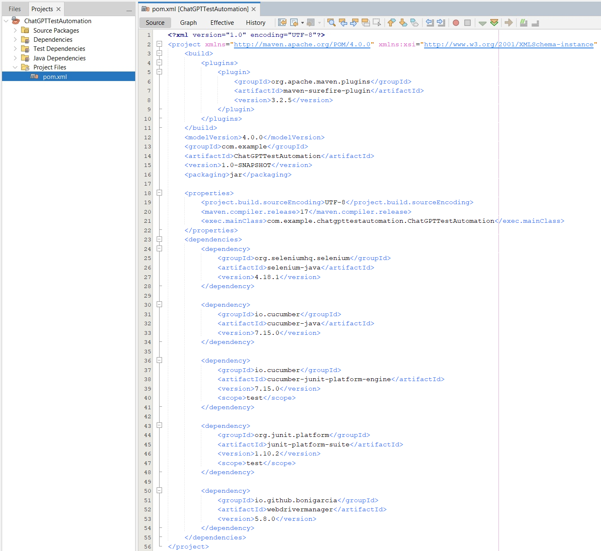

- Project Structure for Cucumber:
For Cucumber tests, a typical project structure involves feature files, step definitions, and a test runner.
- Create feature files: Create a folder src/test/resources/features

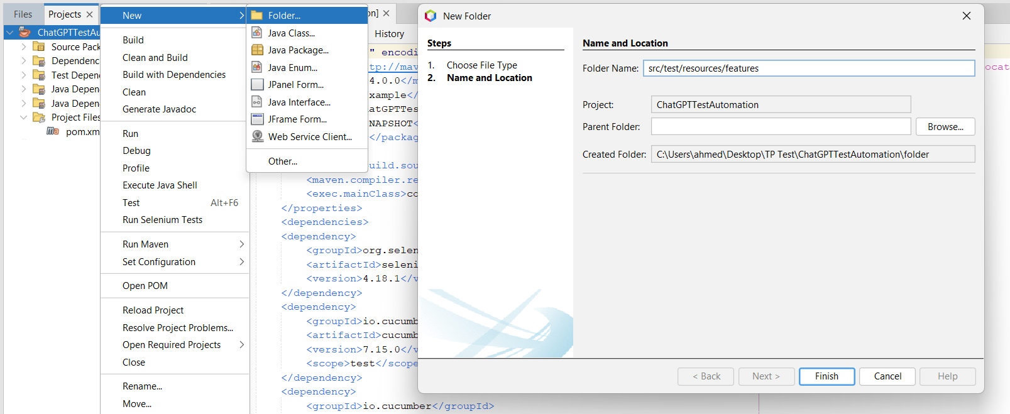

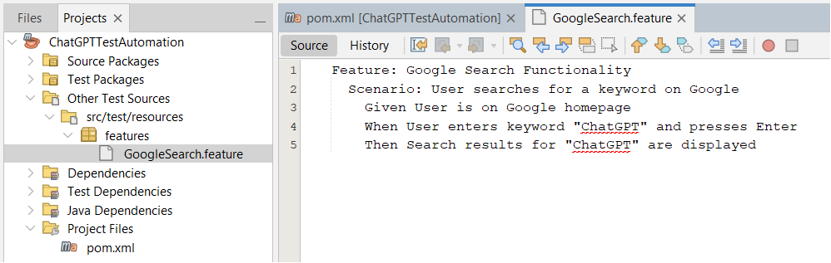
- Create the File ”GoogleSearch.feature”: Write a test plan in a .feature file using a simple language (Gherkin) to clearly describe what we are testing before programming.

- Creating "Step Definitions": Create GoogleSearchSteps.java class to link the feature file steps to Selenium's programming commands.

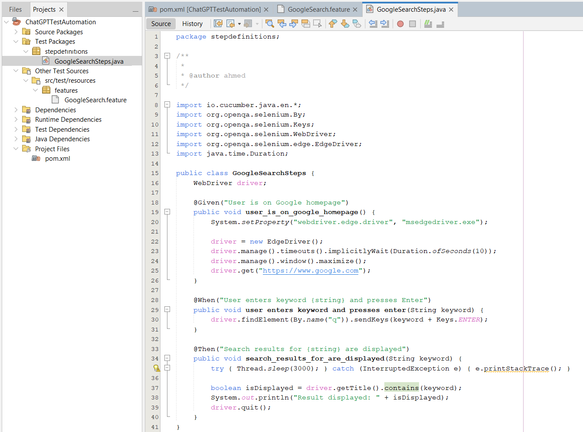

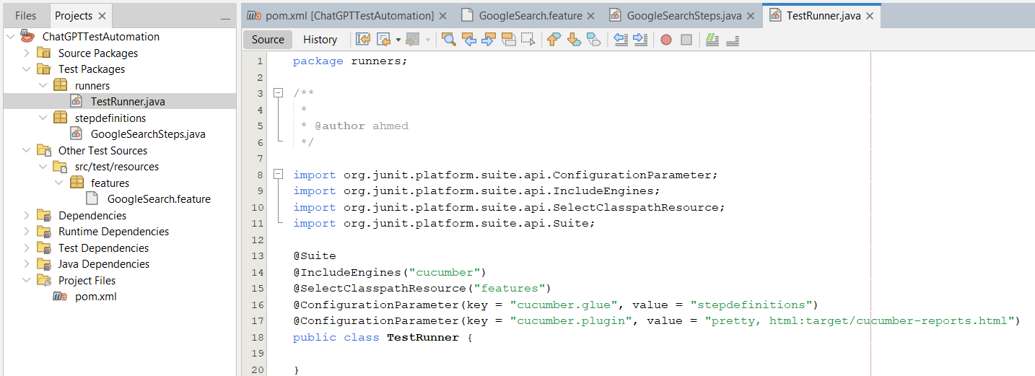
- Create a TestRunner.java class:

- Running Tests:
Right-click on your project in NetBeans and select Clean and Build to download dependencies and compile your code.
The framework will automatically locate the features folder, read the GoogleSearch.feature file, map its steps to the corresponding methods in GoogleSearchSteps.java, launch the browser, and execute the test automatically.
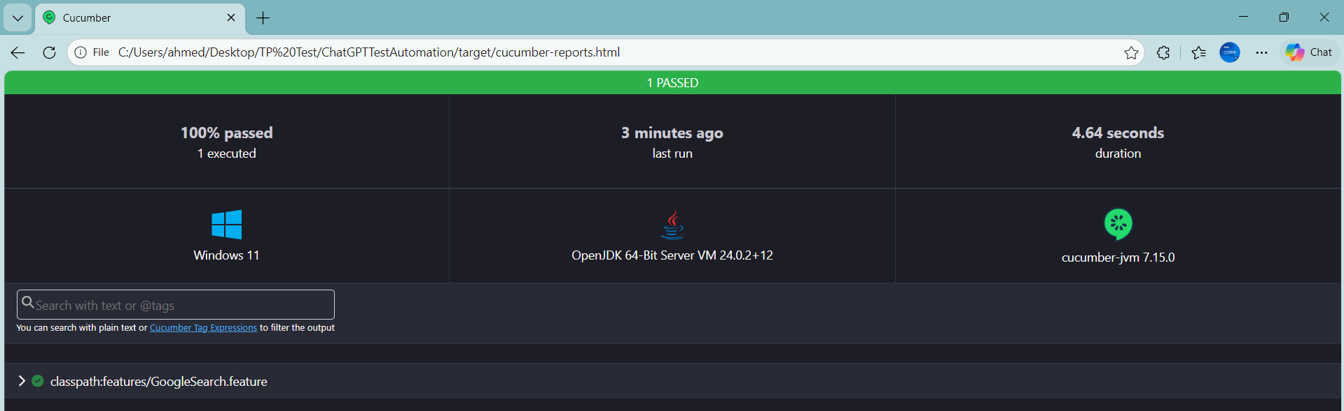

- Integrating with LambdaTest:
Integration with LambdaTest means running your tests on the cloud instead of your local machine, allowing you to test across different browsers and operating systems without needing to install them.
- Obtaining credentials:
You need to have an account on LambdaTest.com. From the Dashboard, retrieve the following details:
- LT_USERNAME: your username
- LT_ACCESS_KEY: your access key
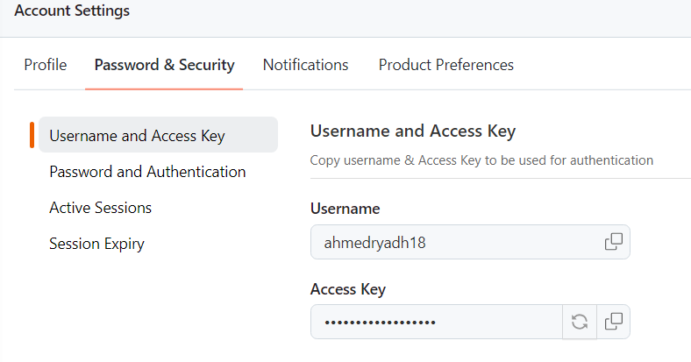

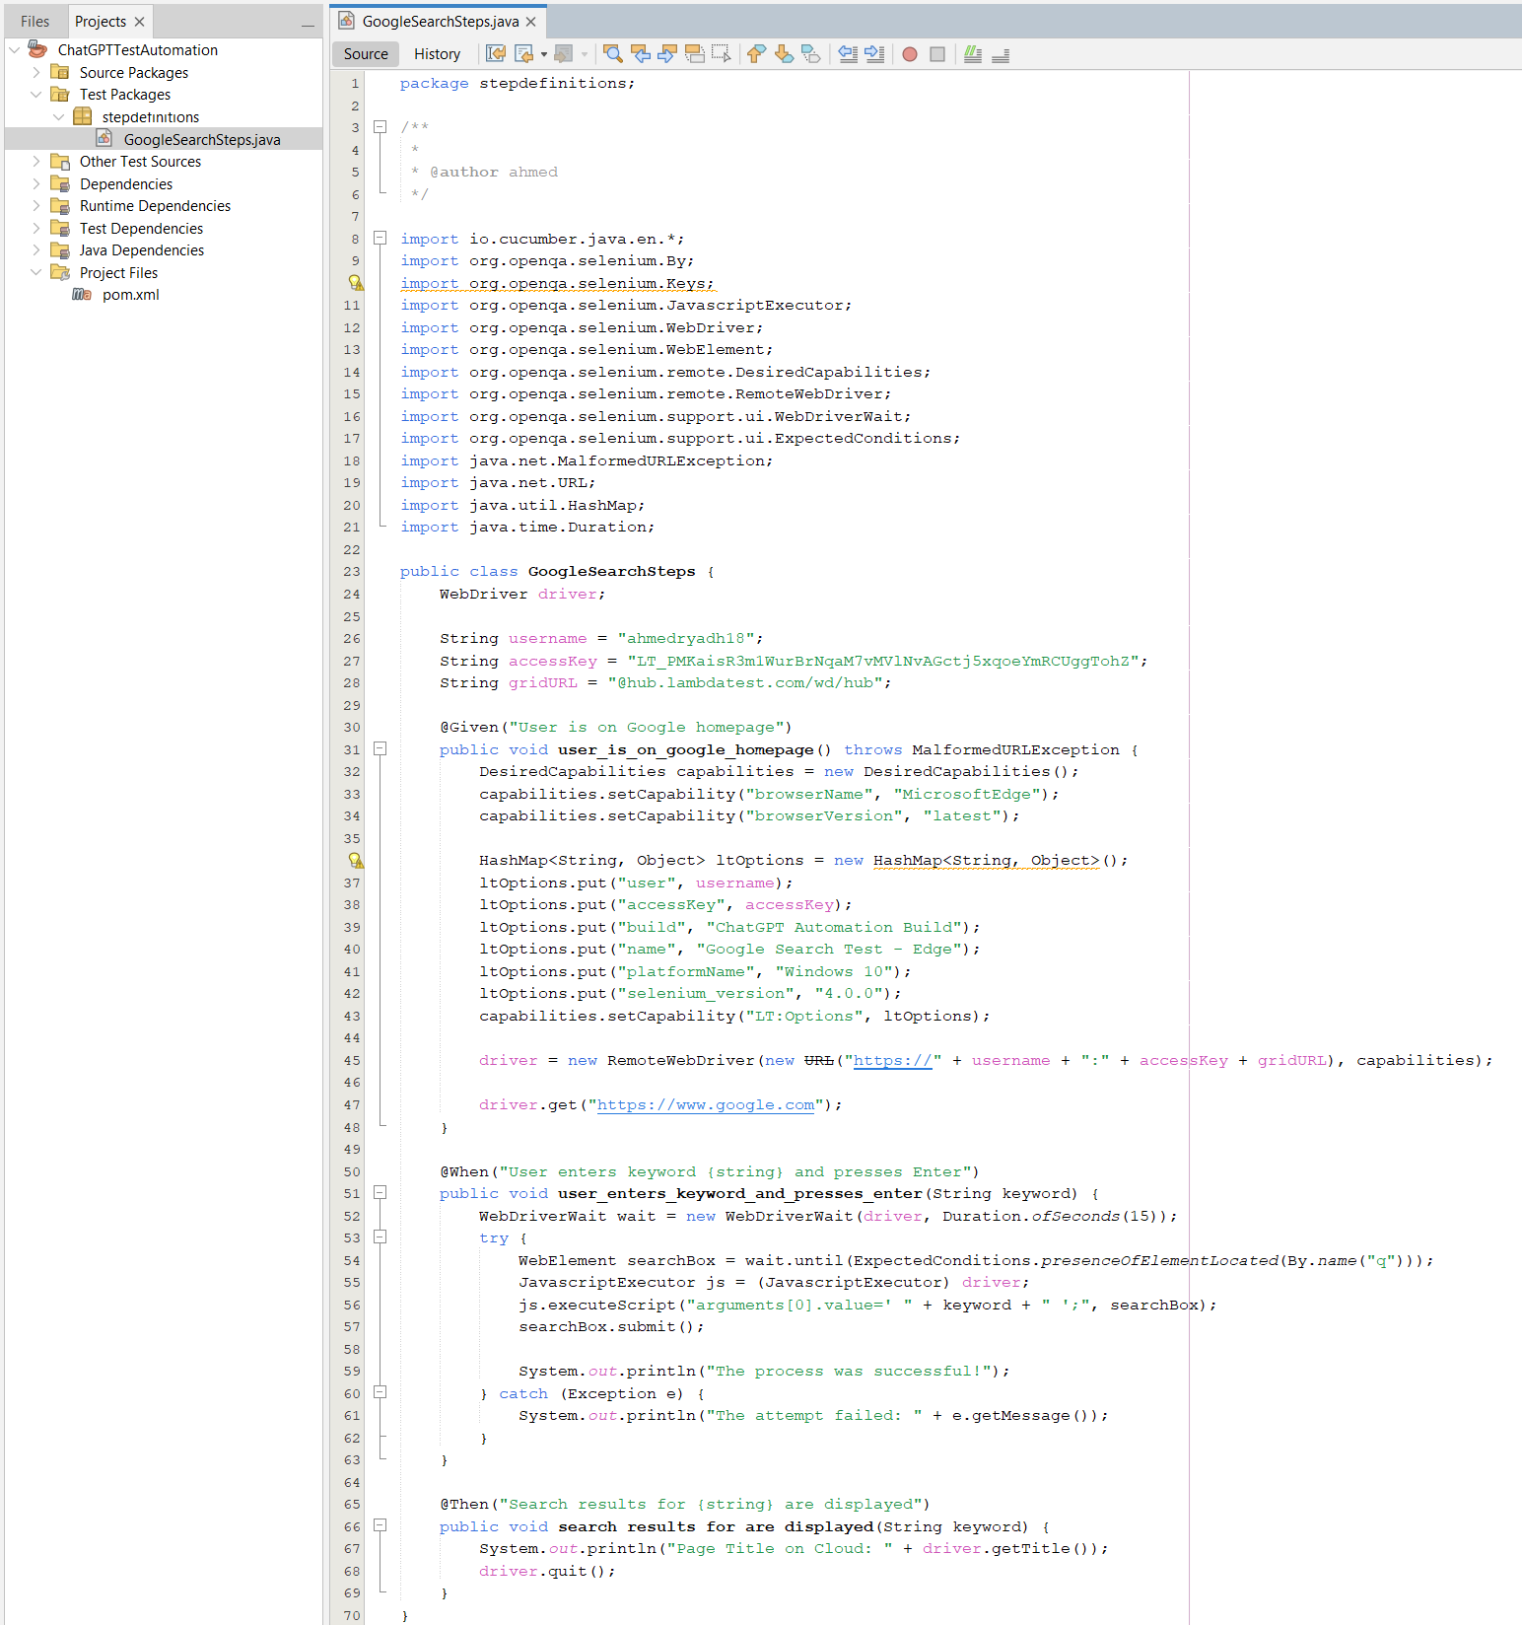
- Update StepDefinitions code:

- Changes in the pom.xml file:
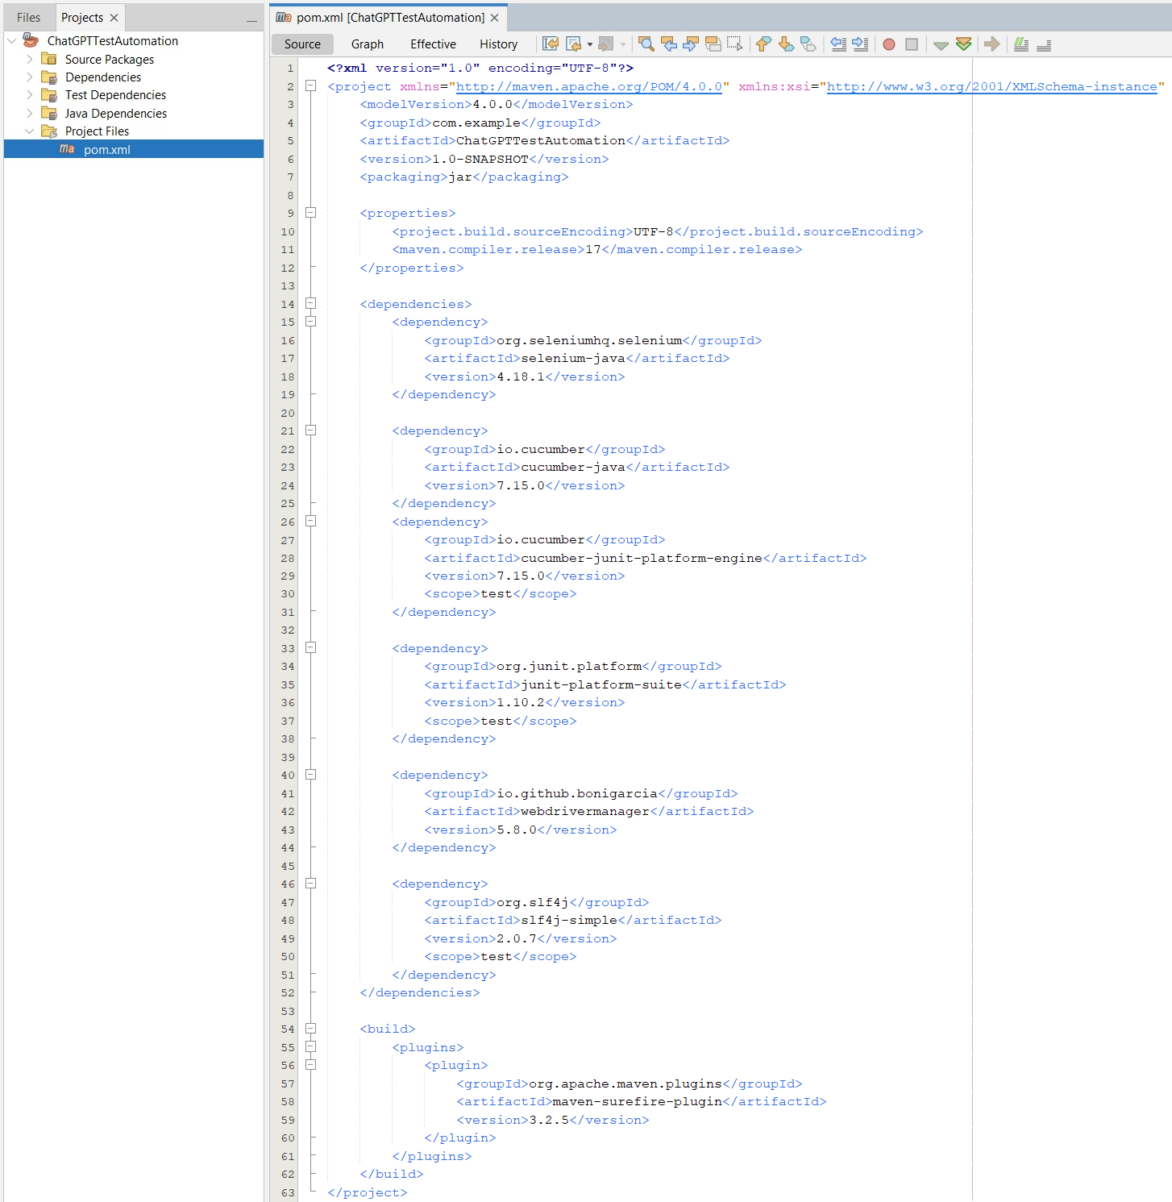

After modifying the file, make sure to press Clean and Build in NetBeans.

- Execution: When you execute the TestRunner, the Edge browser will not open on your local machine. Instead, the code sends the commands to LambdaTest.
You can log in to your LambdaTest account and watch a live stream of the test as it runs on their servers.
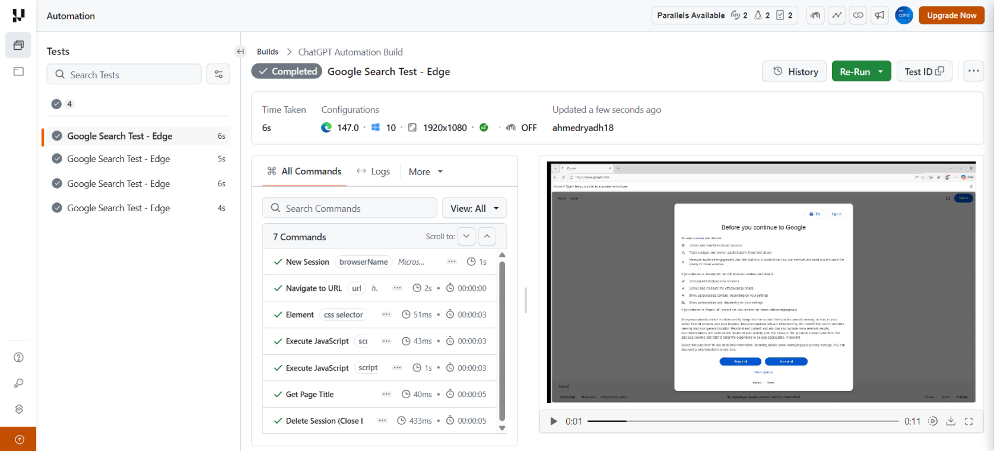

- Negative tests and exceptions:
We will add a negative scenario that tests the search for something that does not exist, and we will develop the exception handling to be more stringent.
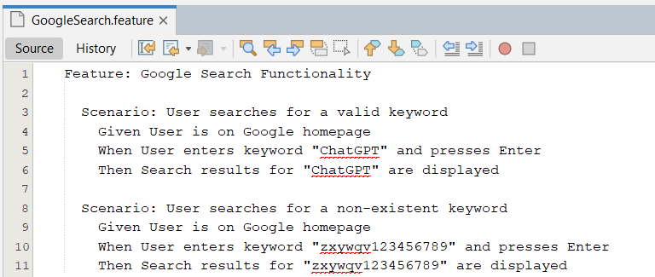
- Adding a negative scenario to the .feature file:

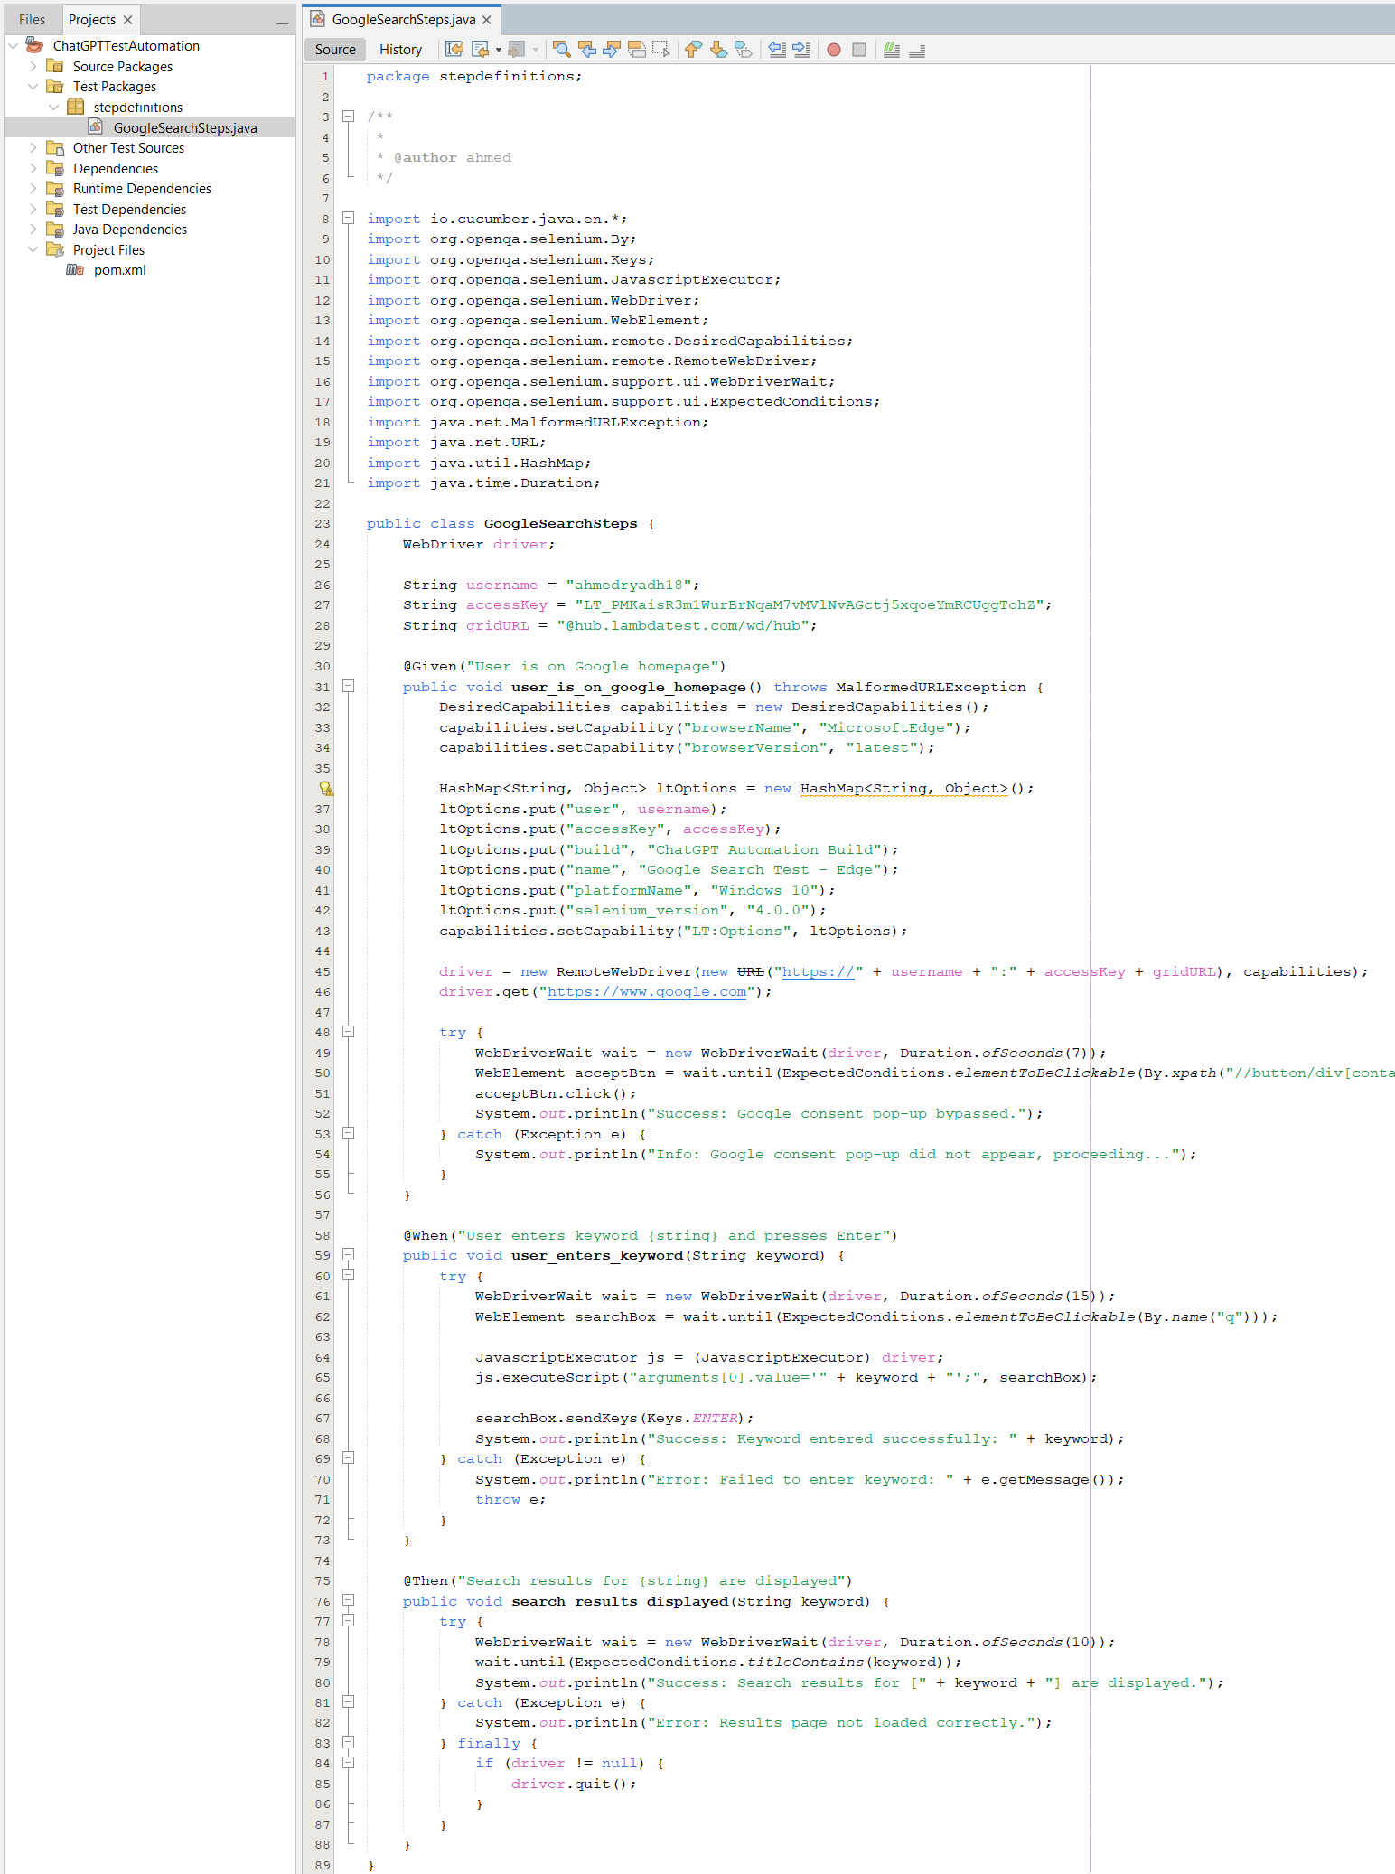
- Modifying the StepDefinitions code:

- Execution: The tests were designed to be Résistante (collapse-resistant) by incorporating Tests Négatifs. Instead of simply verifying success, we tested the system's response to incorrect data and handled exceptions such as TimeoutException and NoSuchElementException to ensure the Test Pipeline continues even in the event of unexpected errors.
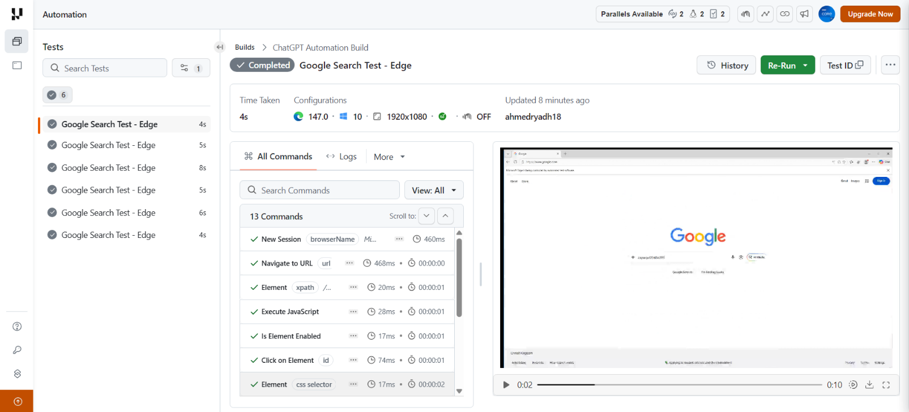

- CI/CD with GitHub Actions:
We will create a "pipeline" that will automatically run these tests when the code is uploaded to GitHub.
- Creating maven.yml file:

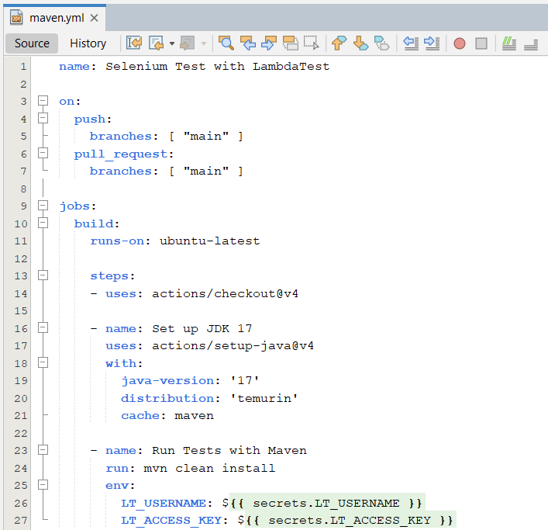

- Implementation of (CI/CD) Pipeline:
1. Local Setup (Git Initialization):
After installing Git, the project folder was turned into a tracked repository:
- Initialized a local repo using git init
- Configured developer identity (name & email) with git config
2. Linking to the Cloud (GitHub):
The project was connected to GitHub for storage and collaboration:
- Created a repository named ChatGPTTestAutomation
- Linked it using git remote add origin
3. CI/CD Pipeline Setup:
Built an automated pipeline using GitHub Actions:
- Created .github/workflows/ directory
- Added maven.yml to define the workflow
- Run tests using Maven (mvn clean install)
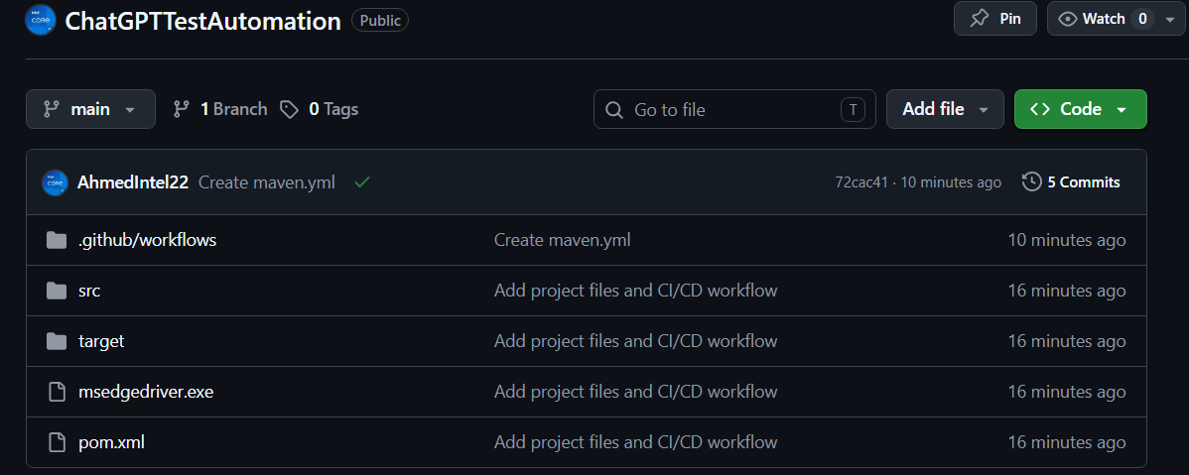

4. Final Outcome:
Every time you push code (git push), GitHub will automatically:
- Start a fresh server
- Build your Java project
- Run Selenium tests on LambdaTest
- Show results in the Actions tab: ✅ Success or ❌ Failure
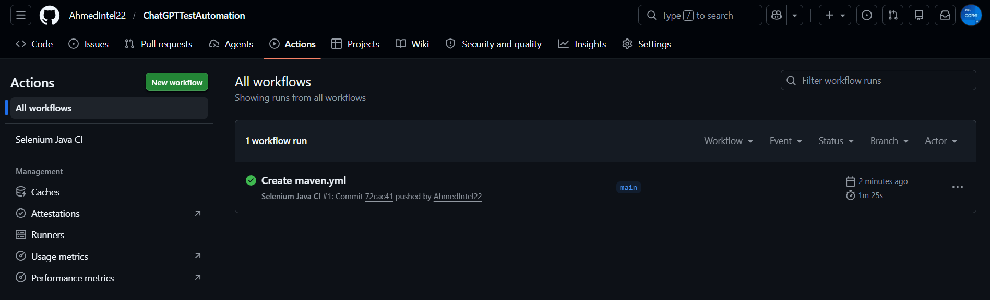

Conclusion
ChatGPT presents a powerful tool for accelerating and enhancing software test automation. While it offers significant advantages in code generation, learning curve reduction, and pipeline automation, users must be aware of its limitations, particularly regarding contextual understanding and the potential for incomplete code. The integration of AI-generated scripts into a robust CI/CD pipeline, combined with professional practices like resilient wait strategies and secure credential management, demonstrates that effective utilization requires human oversight. Expertise is essential to refine, debug, and ensure the overall quality and security of the generated automation artifacts.

TP++:
Testing
using
Python and PyTest

Introduction to PyTest
While Java remains a standard in enterprise environments, Python has emerged as a powerhouse for automated testing due to its "Pythonic" simplicity and readable syntax. At the heart of this ecosystem lies PyTest, a robust testing framework that simplifies the process of writing, scaling, and maintaining complex functional and integration tests.

Why PyTest for Acceptance & Integration Testing?
PyTest is preferred for modern software projects for several strategic reasons:
- No Boilerplate: Unlike JUnit, PyTest does not require wrapping tests in classes or using complex annotations. A simple function starting with test_ is sufficient.
- Powerful Fixtures: PyTest uses Fixtures to manage test setup and teardown (e.g., initializing a database or a web driver). They are modular and reusable, making integration tests much cleaner.
- Parametrization: It allows running the same test logic with different data sets using a single decorator (@pytest.mark.parametrize), which is ideal for testing complex business rules.
- Detailed Assertions: When a test fails, PyTest provides a detailed breakdown of the values involved without requiring custom failure messages.

Practical Implementation in VS Code:
      - Integration Testing Layer
This section demonstrates the practical application of integration testing in Python. We focus on verifying the 'Discount Logic System' to ensure all functional units operate correctly as a unified module.

  - Setting up the Python project
To initiate the automated testing environment within Visual Studio Code, a robust environment configuration was performed. Since the initial environment lacked a pre-installed package manager, the ensurepip bootstrap module was utilized. By executing the command python -m ensurepip --upgrade, the pip installer was programmatically integrated and updated to its latest version.
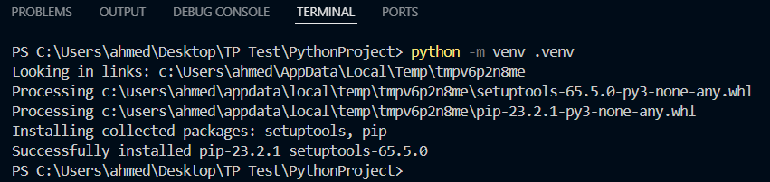

This step was crucial to establish a reliable foundation for installing the PyTest framework and its dependencies. Following this, a dedicated Python Virtual Environment (venv) was created to ensure dependency isolation, preventing any conflicts between global system libraries and the project’s specific testing requirements. This process reflects a professional "Zero-Configuration" recovery strategy, ensuring that the CI/CD pipeline or any development workstation can be provisioned for testing even in restricted environments.

Furthermore, the Python module interface was employed for package management. The PyTest framework was successfully deployed using the command python -m pip install pytest. This approach ensures that the package manager is invoked directly through the verified Python interpreter path. This setup guarantees that the testing toolchain is resilient and ready for integration testing, regardless of the host system's global environment variables.

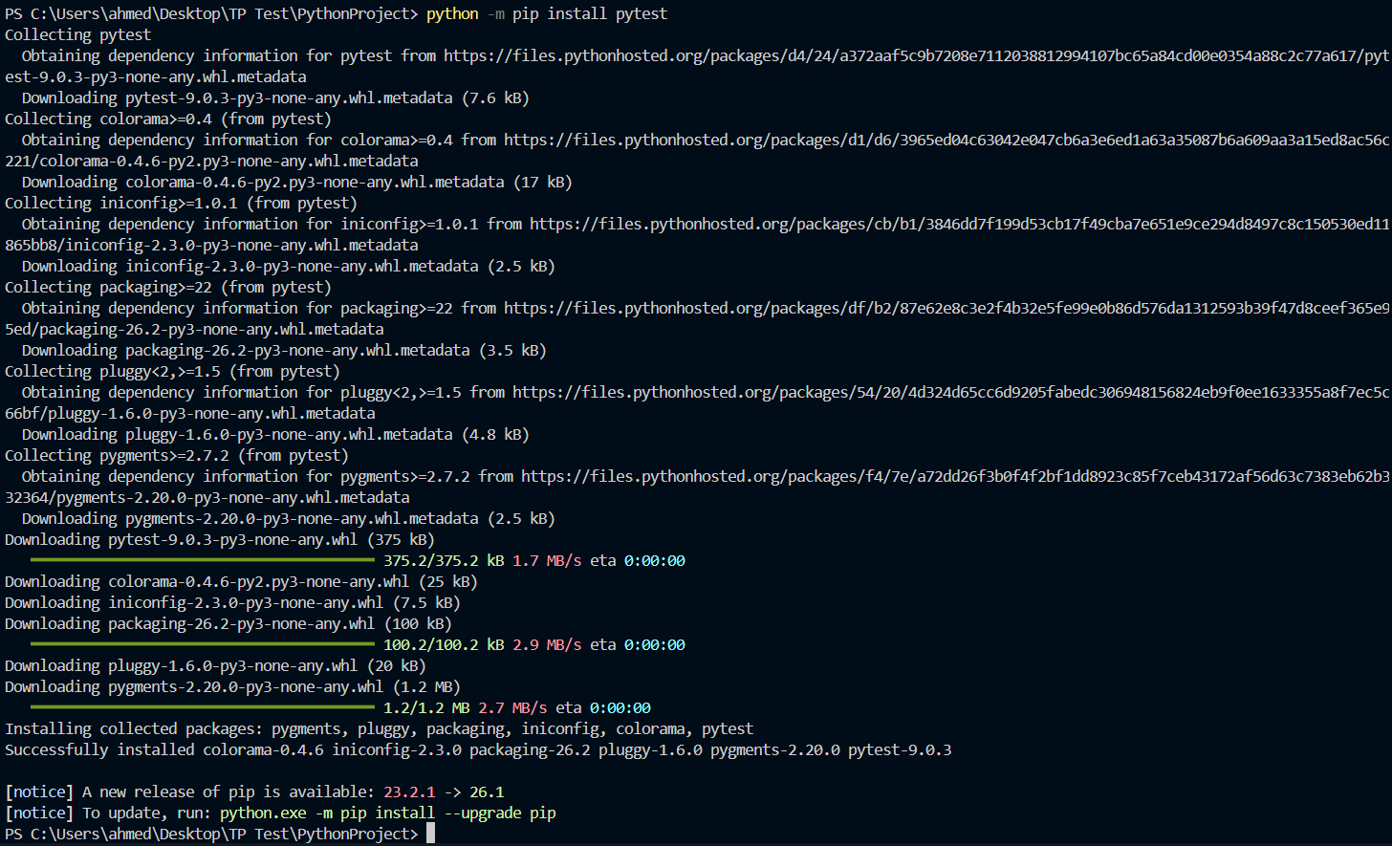

  - Creating the Project Structure
To demonstrate the power of Python, we will use the example of “calculating loyalty points” (which is a classic exercise in integration testing) because it is based on business logic that changes based on different inputs, which highlights the power of PyTest in handling these cases easily.
Technical note: In PyTest, the test file name must begin with the word test_ in order for the program to recognize it automatically.

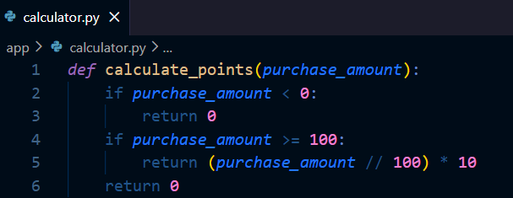
- calculator.py file: 10 points per $100, no points for negative amounts.

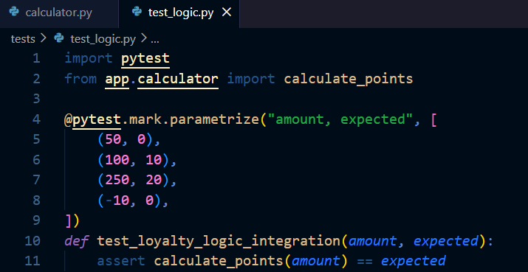
- test_logic.py file: The file containing the tests

- Dependency Management with requirements.txt
To ensure the reproducibility of the testing environment, a requirements.txt file will be created. This file acts as a manifest for the project's dependencies, primarily the PyTest framework. By utilizing this standardized approach, any developer or automated pipeline can replicate the exact environment using the command pip install -r requirements.txt. This step is a cornerstone of modern DevOps practices, ensuring consistency across development, staging, and production environments.

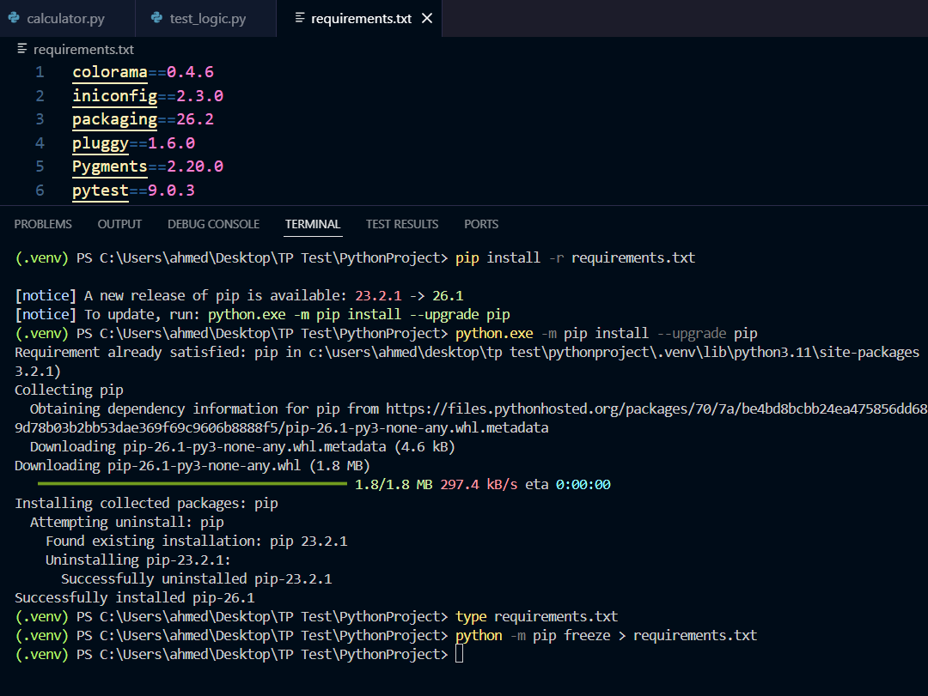

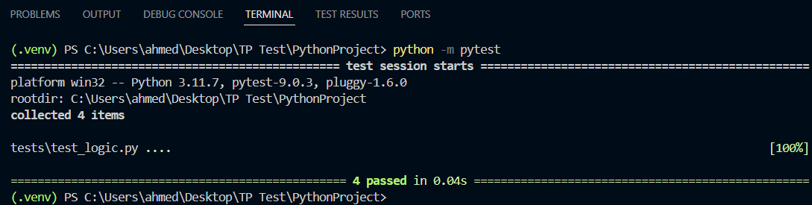
- Running the test

The figure above illustrates the successful execution of the integration test suite within the VS Code Terminal. By running the command python -m pytest, the framework automatically discovered the test cases defined in test_logic.py. The output confirms that all 4 test scenarios, validating the efficiency and accuracy of the Python-based testing environment.

      - BDD Acceptance Layer
The BDD Acceptance Layer serves as the final validation stage, ensuring that the software meets the pre-defined business requirements. By integrating Pytest-BDD, we translate technical scenarios into human-readable Gherkin specifications, bridging the communication gap between stakeholders and developers.
  - BDD Toolchain Setup
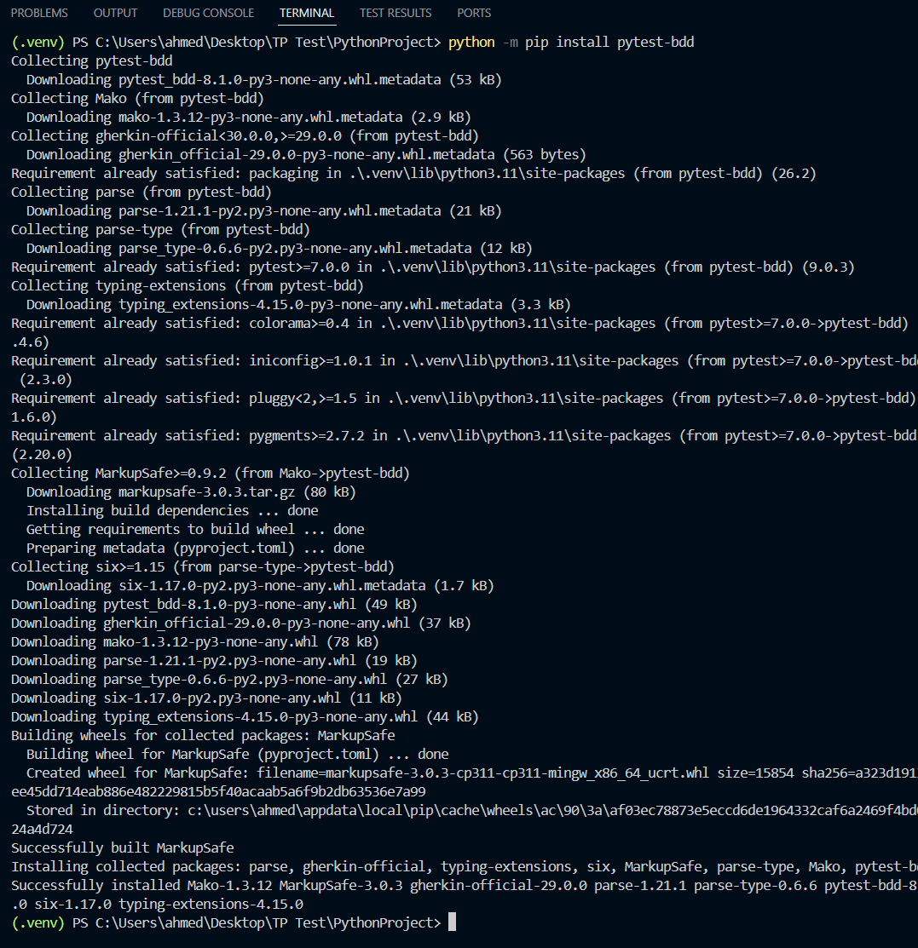
To enable Behavior-Driven Development capabilities within the Python environment, the pytest-bdd library will be installed. This was achieved by executing the command python -m pip install pytest-bdd, which provides the necessary integration between Gherkin feature files and Python test scripts.

  - BDD Writing an acceptance script (loyalty.feature)
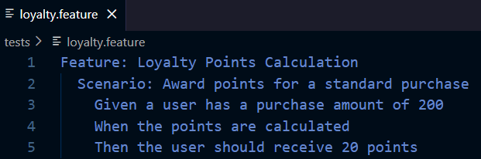
This is the file that the "client" or "project manager" reads

  - Link scenario to code (test_logic.py)
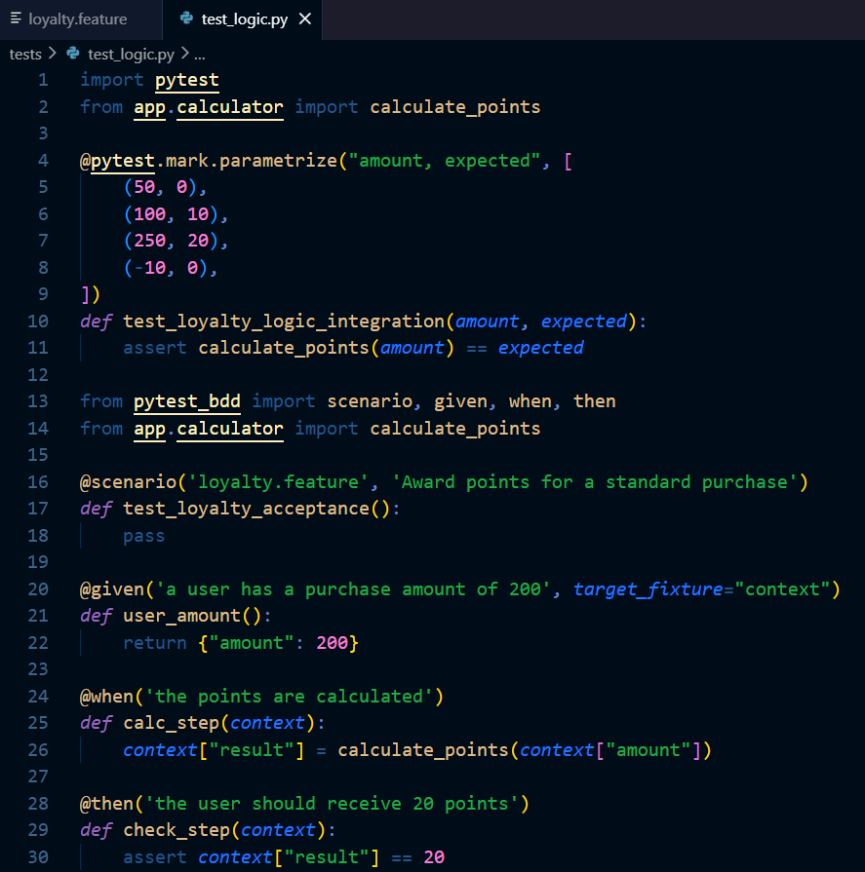
We will update the test file to read the Feature file

While the previous tests focused on integration, Acceptance Testing ensures the system meets business requirements. By integrating pytest-bdd, we bridged the gap between technical code and business language. We implemented a Gherkin feature file to define the 'Loyalty Points' criteria in plain English. This ensures that the final product aligns perfectly with the stakeholder's expectations, maintaining a consistent BDD workflow across both Java and Python environments

  - Running the test
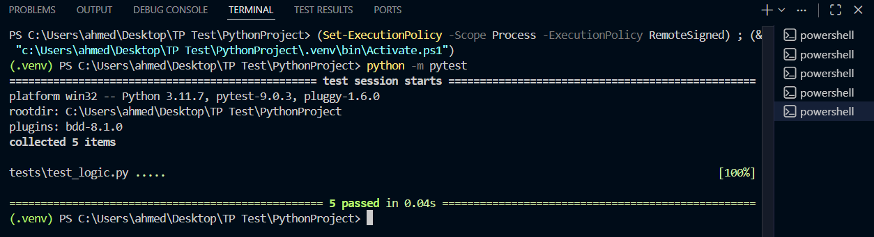

Upon the final execution of the test suite using the command python -m pytest, the system successfully collected and executed 5 test items. This increase from the initial 4 integration tests confirms the successful incorporation of the BDD Acceptance Scenario.
The output showed a 100% pass rate, confirming the success of two critical layers in the QA process:
- Technical Integrity: The 4 parameterized integration tests confirmed that the discount logic handles various boundary and edge cases accurately.
- Business Alignment: The 5th test—the BDD scenario—confirmed that the system behaves exactly as defined in the Gherkin feature file.
This hybrid execution demonstrates a complete testing lifecycle, ensuring that the code is not only mathematically correct but also functionally compliant with business requirements.

Is there an alternative to Java's Spring in Python?
Yes, there are very powerful Python alternatives that perform similar functions to what Spring (or Spring Boot) does in Java, but with Python's philosophy of simplicity and speed.

1. FastAPI (The Modern Alternative to Spring Boot)
FastAPI is one of the closest Python alternatives to the spirit of Spring Boot, especially for API-driven projects. It offers native dependency injections, high performance, and uses Pydantic for automatic data validation—similar to how Spring manages POJOs.
2. Django (The Comprehensive Alternative - Enterprise Level)
Django is a powerful full-stack framework comparable to the broader Spring ecosystem, offering a robust ORM similar to Hibernate/Spring Data JPA, strong built-in security, and an integrated admin panel—making it ideal for large, complex applications that require solid architecture.
3. Flask (The Flexible Alternative - Microservices)
Flask offers lightweight flexibility similar to early-stage Spring Boot, providing a minimal foundation that allows developers to choose their own libraries, making it a popular choice for simple microservices and modular applications.

Comparative Analysis: VS Code vs. Anaconda for Testing
While Visual Studio Code and Anaconda both support Python testing, they cater to different workflows.
VS Code excels in Integration Testing due to its lightweight nature and superior terminal integration, allowing for rapid execution cycles as seen in the pytest output. It offers a developer-centric experience with extensions that visualize test suites directly in the sidebar.
On the other hand, Anaconda (via Spyder or Jupyter) is more suited for data-centric Acceptance Testing. Since acceptance criteria in data science often involve verifying model accuracy or data integrity, Anaconda’s integrated scientific libraries and variable explorers provide a better environment for stakeholders to validate results.
However, for a streamlined BDD (Behavior-Driven Development) workflow, VS Code remains the preferred choice as it handles the file structure of tests/ and .feature files more intuitively, facilitating a smoother transition between technical code and business requirements.

Conclusion
The integration of Python and PyTest into this project has successfully demonstrated the agility and efficiency of modern testing frameworks. Despite the initial environment constraints, the use of ensurepip and a Virtual Environment (venv) ensured a stable and isolated platform for development.
By implementing both Parameterized Integration Tests and BDD-based Acceptance Testing, we have achieved a dual-layer validation strategy. The final execution of 5 successful test cases confirms that the system is technically sound and business-aligned. This phase of the project proves that Python is an invaluable tool for rapid, scalable, and highly readable automated testing, perfectly complementing the robust standards established in the previous Java modules.

